.. A *I*

**COi'i)i:ci.U** If-; 0



###### i>On i=OLiO " '

Servicios de l mpresi6n Dig fol

Campus Univcrsitario de Habanalcs

957 212 041

clonfolio:[111Ltrio@111co.es](mailto:111Ltrio@111co.es) - clon[folioapuntcs@gmaiI.corn](mailto:folioapuntcs@gmaiI.corn)

INF-29 CAMPUS UN IVERSITAR IO DE RABANA LES

TITULACION:INFORMATICA

GRADO: 2Q

ASIGNATU RA: SISTEMAS DE IN FORMACIO N MATER IA: PMCTICAS



CUATRIMESTRE: 2Q GRUPO:

PROFESOR: PEDRO GONZALEZ FECHA DE ENTREGA: 04/02/15 PRECIO: 1,90€

NOTA:La caratula de esta entrega no esta cobrada.

 

Scanned by CamScanner

**CHAPTER 1**



**Bad BPMN, Good BPMN**

BPMN stands for *Business Process Model and Notation.* Par the vast majority of BPMN users, the most important part is the N - the graphical *notation* - a diagramming language for business process flows. The most important thing about it is that it is a *standard,* maintained by the Object Management Group (OMG). That means it is not owned or controlled by a single tool vendor or consultancy. You pay no fee or royalty to use the intellectual property it represents. Today, virtually every process rnodeling tool supports BPMN in some fashion, even though a fe\"-' vendors may grumble that their own proprietmy notation is better or more business-friendly.

A key benefit of a process modeling standard is that understanding is not limited to users of a particular tool. The semantics are defined by the standard, not by each tool. BPMN is an *expressive* language, able to d1:-scribe nuances of process behavior compactly in the diagram. At the same time, the meaning is precise enough to describe the teclmical details lhat control process execution in an automation engine! Thus BPMN bridges the worlds of business and 11,' a common process language that can be shared between them.

**The Paradox of BPMN**

l3PMN's popu1arity begins with its *outward familiaritt;,* especially to business people. Its boxes and arrows, diamonds and swimlanes looka lot like traditional flowcharts, which have been

arou...nd. .*£01* 25 years. And that was by design. But here is the paradox of BPMN. While outwardly familiar, BPMN's unique capabilities come rom ways in which it *differs* from

traditional flowcharting.

One difference,as mentioned above,is that modelers may not make up their own meaning for the standard shapes and symbols. BPMN is based on a formal *specification,* including a metamodel and rules of usage. Its expressiveness derives from the extensive variety of markers,icons, and border styles that precisely refine the meaning of the basic shapes. It has

3

----·--···**··-----·-·--···--------,_,,.., _.,. _ ,.e..s."?&"!4'.J.,t.<.J..,C,,«""""'--**

**Scanned by CamScanner**

*rules* that govern the use of each shape, what may connect to what. Thus you can *validate* a

BPM"!'-1' model, and any BPMJ:-J tool worth using can do that in one click of the mouse.

A second key difference from traditional flowcharts is that BPMN can describe *event-triggered behavior.* An event is "something that happens"while the process is underway: 'Ihe customer calls lo change the order; a service level agreement is in danger of being violated; an expected response docs not arrive in time; a system is down. These things happen all the time. If our model represents the "real" process it needs to say *what should happen* when .those exceptions occur. BPMN lets you do that, and visualize that behavior in the diagram itself.

Third, in addition to the solid *sequence flow* connectors depicting flow *within* a process, BPMN describes the communications *between* the process and external entities like the customer, external service providers, and other inteti:tal processes. Those communications are represented by a dashed onnector, called a *messageflow.* The pattern of message flows, called *collaboration,* reveals ho'tv the process fits in the global envirorunent.

Thus, using BPMN correctly and effectively requires learning the parts of it that are *unfamiliar.* It's not hm·d, and that is what this book is about. Nevertheless, folJowing the release of BPMN 2.0 in 2010, we began to hear some people say that understanding BPMN is ''too hard for business people." Usually the people saying it were tool vendors or consultants wedded to their o·wn legacy notations.

But let's concede one point: there js a lot of "bad BPMN" out there, diagrams that are invalid, incomplete, or ambiguous. But that does not mean:that creating "good BPMN" is beyond the reach of business users. I suspect that if you looked at a sampling of college application essays you would see a correspondingly high frequency of misused words, grammar errors, and garbled sentence structure. Should you conclude from that that English is just "too hard for high school students"? No, a language *requires* richness in order to express complex ideas. But you need to teach people how to use it correctly and effectively, and provide tools to help them do it.

**Method and Style**

That's what this book fa about. It shows you how to create "good BPMN," meaning models

that are:

..

* Correct. The diagram should not validate the rules laid out in the BPMN

specification.

* Clear. TI1e process logic should be unambiguous and obvious from the diagram alone. It should not depend on attached documentation. · Note the term *process logic* means the logic of proceeding from .one task to the next, not the details of how individual tasks are pel'formed. ·
* Complete. In addition to the activity flow, the diagram should indicate how the process starts, all of its significant end states, and its communications with external entities, including the requester, service providers, and other internal processes.

4 I Chapter 1.Bad BPMN, Good BPMN

Scanned by CamScanner

~~·· -::-=-~~



* Consistent. Given the same set of facts about the process logic, a11 modelers should

create more or less the same 13PMN model, or at least models that are similarly

structured. Consistency across the organization makes modelc; easier to share and understand .

The BPMN spec demands only correctness, but this is insufficient fr good BPMN. Good

BPM".l\J requires adopting conventions that go beyond the requirements of the specification. I call those conventions *BPM N Method and Sh;le.*

The Method I present in the book is a prescriptive recipe for turning a blank page into a BPMN model that is correct, clear, complete, and consistent. Jt is less important that you adopt my Method exactly than you estabJish some kind of prescriptive process rnodeling methodology for use across your organization. Consistent model structure maximizes shared understanding as well as model reuse across the organization.

TI1e Method and Style npproach is *top-down* and the resulting models have a *lziertrchical* structure. *Style* refers to basic principles of composition and element usage that go beyond the official rules of the spec. I used to teach BPMN style as r'best practices," but I have found that it is more effectiv.e to reduce it to a list *of rules that can be validated in the tool,* ju.-;t like the official BPMN rules.



Model clarity is directly related to the style rnles, many of which simply have to do with labeling. For some reason, beginnig modelers are extremely stingy with labels, and the BPMN spec does not requfre any labels at all. But when you think about it, all you have in the diagram to conununicate meaning are shapes and labels. In hierarchical models, where process levels are represented on separate pages, labeling is what makes the procc5s logic traceable from the top lvel down to the lowest level of detail:

**The Long Road to BPMN 2.0**

For most modeler.s the important part of BPMN is the *N,* the graphical *notation.* But most of the effort in creating BPMN 2.0 involved the *M,* the *model.* That means the formal semantics

of the element definitions and their inter-relationships, as defined by a formal *metamodel* and

its corresponding XML representation. The notation, the shapes and symbols, actually changed very little from BPMN 1.2 to BPMN 2.0.

One key motivation for the shift in focus in BPMJ"J 2.0 was to provide an official Xi\1L *intt!Tchange format* for process models. A second was the wish on the part of major BPM Suite vendors *..:._* i{()tably IBM, Oracle, and SAP - to make BPMN models *executable* in a process engine. .Actually, many BPM Suites were a]ready basing executable process design on BPMN

1.x, but they each modeled the execution-related details in their o·wn proprietary way. BPMN

2.0 would standardize the representation of process data, messages,services, task assignment

and the like, not be inthe diagram but in the XML underneath.

OMG's focus on process execution Jed to a bit of a backlash against BPMN 2.0 from some in the BPM community, but the fact remains that the vast majority of BPMN 2.0 use is still for diagramming non-executable processes. BPMN 2.0 adds only a couple important new

Chapter **1.** Bad BPMN, Good BPMN I 5

**Scanned by CamScanner**



graphical elements to the notation: non-interrupting events and data store. But the tension between BPMN as a busm· ess-fn·endly ch·agramnu·ng notation and BPMN as an executable process language has been there from the beginning.

BPMN originated in 2002 as the visual design layer of a new type of "transactional wor.kflow" system from a consortium called BPMLorg, led by a startup named lntalio. Leveraging the distributed standards-based architecture *of* the web and web services, *this* new type of BPM would be a radical break from the proprietary workflow systems of lhe client/server era. One key difference would be making the process execution language a *vendor-indepem:lent standard.* As it developed the language, called BPML, BPMl.org reached a peak of 200 members, essentially all the major software vendors except IBM and Microsoft. ·

Another difference would be *business emprr.oerment .* "In a nutshell,'' recalls BPMI's founder Ismael Ghalimi, "it would allow less-technical people to build transactional applicntions by drawing simple flow charts."6 BPML would not be coded by hand but *generated fram a diagram,*which- would also be standardized: BPl\AN. Existing process diagramming startdards like UML were rejected as too IT-centric. BPMI demanded something more business-friendly. Howard Smith and Peter Fingar fleshed out the promise of business-empowerment through BPMN in a seminal 2002 book, *BPM: 111e Third Wave,* which correctly predicted that empowering business people to manage their own processes was critical to the evolution *of* BPM.



BPMI.org produced a spec for BPMN 1.0 in 2004. Ghalimi continues: "Among [the BPMI members were] very many process modeling tool vendors who loved the idea of a standard notation for processes, and very many workflow vendors who hated the idea of a standard language for executing them. The former understood that they could provide a lot *of* value around the core process modeling tool. The lotter knew all too well that fragmentation of the market helped preserve the status qua..."

I

l

As it turned out, no one had anything to.fear from BPML. IBM and Microsoft countered with BPEL, a slightly different language layered on top of the new web services standard called WSDL. In an instant those two vendors trumped 200,and BPML was effectively wiped oul In 2005, needing a new home, BPMI.org was absorbed into the Object Management Group, ironically home of the spurned alternative, UML. OMG formally adopted the BP.MN 1.0 spec in 2006, adding a minor update, BPMN 1.1, in January 2008, and BPl'v.tN 1.2, a bug fix, a year after thal

I

·-It's a familiar cycle in the world of *IT* standards, one that normally leads to quiet oblivion. By the end of 2008, however, against all odds,JJPMN turned out to be not on the road to oblivion but approaching a tipping point of mass adoption. 111e explanation is simple. Smith and Fingar were right... sort of. Business empowerment *is* the key to BPM, and BPMN provides that -not the executable code, but the precise flow logic that code would have to implement.

6 For a fusthond account, see Why l *This* Matters, Ismael Ghalimi, <http://jtredux.com/2008/10/24/why-all-this-matters/>

6 I Chapter 1. Bad BPMN,Good BPMN

/ .



Scanned by CamScanner

Even though the BP.MN specification made no explicit.distinction between its elements that are part of the non-executable *model* and those required for executable *implementation,* it is



pretty obvious which is which . 1he "model" elements are displayed in the diagram; the execution-related elements are not. .

The BPM Suite vendors simply adopted the *modcling* parts of BPl'vfN 1.x - the diagram -and ignored the *execution* parts. Executable details could be added to the process model, but each BPN!S would do this in its own way. 1lms BPMN 1.)( - as implemented by the majority of modeling tool und BPMS vendors - is not by itself executable, although it is incorporated in many vendor-specific execu table design tools. And tha t suits the vast majority of process modelers just fine. Few are even thinking about execution in a BPl'vLS, anyway. They are business analysts and process architects, not developern.

BPMN 1.x failed, however, to deliver on a key promise, intcrchnnge between modeling tools. Irs amazing that BPMN has achieved ,.,,-ide adoption without that, but somehow it was never a priority at either BPMI.org or OMG.Stnndnrdi7.ing the XML serializa tion, based on a formal

*metamodel,* would be a key goal of BPMN 2.0.

In fact, OMG originally intended simply to take its mvn *Business Process Definition Metamodel (l3PDM )* and rebrand it as BPMN 2.0. Itwould de-emphasize the graphical notation and focus on abstract semantics that could be mapped to *any* process modellng language. However, that was a mistake. It would not only abandon existing BP vlN l.x users but did not sit well with IBM, Orade, and SAP, who needed to bridge the gap between SOA and business-oriented BPM. They wanted to *extend* the BPMN 1.2 notation, popular with business, to include



executable design. In the end, their rival propoS<Jl carried the day.7

In world of BPM tools, BPMN 2.0 marks a tipping point. BPMN 1.x adoption was spearheaded by the small BPMS "pureplay" vendors. With BPMN 2.0, the biggest software companies in the world are leading the charge. Today any other notation *is* seen as "proprietary" or "legacy." Somehow, against all odds, BPMN has become *the* important standard in BPM

**Business Process Modeling Is More Than BPMN!**

Business architects and other BPM practitioners never cease to remind me that the activity flow logic, as defined by BPMN, is only one component of the modeling needed to properly describe, analy-.ce, transform, and optimi.zc a company's business processes. I don't disagree · with·this;·BPMN really just describes the sequencing of process activities. That encompasses quite a lot, but admittedly a lot more information is needed to do BPM properly.

So what ismissing? I asked Brett Champlin, president of the Association of BPM Professionals [(www.](http://www/)abpmp.org) and a BPM practitioner himself at a major insurance company, what

7 In December 2008,somewhat by accident, I joined the IBM-Oracle-SAP submission team, and remained active until publication of the beta specification in the sununer of 2009.

Chapter 1. Bad BPMN, Good BPMN I 7

Scanned by CamScanner

additional information should be modeled to support a process manager in an enterprise DPM program. He gave me a long list, which I have rearranged as follows:

Enterprise or Line of Business

* High-level business context, describing the business's relationships to Competitors, Regulator s,Suppliers, Business Partners, Customers, Community, etc.
* Strategic Objectives and Performance Metrics
* Controls and Constraints
* Markets, Customers
* Products (goods and services)
* Locations

Operational, Cross-Process

* Value Chains and Process Portfolios
* Operational GoaJs and Objectives
* Policies
* Performance Menics and KPis
* Organizational Shi.1cture and Roles.

Process-Specific

* Activity resource requirements
* Revenue and Costs, both activity-based and resource-based
* Job Aids (instructions for human performers)

Technical

* IT Systems
* Sen1ices
* Data

Each of these items can be described by one or more models and attachments, linked insome relationship to the BPMN model. The fact that BPMN itself des not include them is not, in my view, a deficiency. In fact, a single vendor-neutral standard describing all of these models and their interrelationships would be nearly impossible to create. A key teason why BPMN is so widely accepted as a standard is that it does not attempt to do too much.

BPM at the enterpi:ise level requires a suite of tools built around a *repository,* a database that maintains the relationships between all of the different models, along with governance and

.change impact analysis.So-called *Business Process Analysis (BPA) suites* link the process model

to models of business rules, organizational roles, strategk goals and problems, and master data. *Enterprise Architecture (EA) suites* link the BP!v1N to technical . models and executable artifacts. Today, many BPA and EA suites are either replacing their legacy process modeling tools with BPMN or adding BPMN as an alternative format.

8 I Chapter 1.Bad BPMN,Good BPMN





- ----- ;e. - ·- -----=-=----- --------

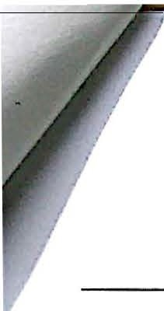

..

r

.

*i*

J

I

i

**CHAPTER 2** '

**How Does A Model Mean?**

A process model is more than a drawing: Its purpose is to convey meaning, specifically the logic of the activity flow from process start to end. From the diagram alone, the process logic should be clear and understandable to a business person but semantically preci.<ie, as required by a developer. By *process logic,* we mean a description of all the paths from a single initial state of a process instance to each of its possible end states.

The BPMN specification and most books about it focus on classifying the BPMN elements in isolation, defining the meaning of each shape and symbol. But, as John Ciardi wrote in his classic, *How Does a Poem Mean?,* "the language of experience is not the language of classification." Effectively communicating the process logic requires understanding how the elements fit together, not just as isolated words but as sentences, paragraphs, a complete story. That requires attention to the overall structure of model, following a consistent set of conventions, what I call Method and Style. If you do that correctly, the most important features of the process are obvious at a glance: what the instance represents,·how the process startc:;, its various possible end states and their corresponding status messages, and its touchpoints with external entities.

The BPMN diagram is both a visualization and a data entry device for the underlying XML *semantic model.* When you draw a diagram, the tool transparently translates each shape into its corresponding semantic element:a start event, a User task, an end event, etc. In the BPMN

2.0 specifictin, the BPMN metarnodc], element definitions, and associated rules all reference the semantic elements, not the shapes in the diagram. In fact, BPMN allows a semantic model without an associated graphical model. That is, the process logic is defined in the XML, but there is no diagram. However, the converse is not true: Jn BPMN 2.0, you cannot have a graphical model without an associated semantic model.

A computer may be able comprehend complex process logic expressed as pages of XML, but people cannot. We need the diagrammatic representation to make sense of what is going on. But here's the problem: Just a tiny fraction of the information defined by the semantic model

9

**scanned *6§* CaM§8anner**

is visible in the diagram: the basic element type, indicated by its shape and associated icons and markers, and a text label. If we are viewing a multi-page diagram within a BPMl'\l' tool, hperlinks can indicate certain relationships between the pages, and property seets cn d1splay various attributes of a selected .shape. But we carmot assume that the diagram is always accessed through the tool. In most cases users view the BPM.1"\f diagram as a hard copy or pdf, inwhich the hyperlinks and property sheets do not appear.

That means we need to convey as much meaning as possible from the diagram by itself, as H ould appear in printed form, where all we have are shapes and labels. *Labels* are very important. A key piece of the Method and Style approach deals with consistent labeling, so the process logic isnot only clear on the page but traceable from page to page in a hierarchical

model.

We don't want to guess the modeler's intent. It should be obvious from the ,diagram alone. That's what we mean by "good BPMN," and fortunately,it is a readily 1eamab1e skill.

BPMN's Hidden Conceptual Framework

While BPMN is widely adopted, few process modelers know how to use it correctly or effectively. Bad BPMN is the norm rather than the exception. One reason is the BPMN specification itself. It fails to explain clearly the meaning of BPMN's most fundamental concepts, like *activity* or *process .* That failure creates problems not only for begfoning process modelers but for experienced business process architects.

*What Is an Activity?*

Let's start with *activity.* An activity in BPMN is an *action,* a unit of work performed . It is the only .BPMN element.that has a *perjonner.* But the meaning of a BPMN activity is more specific than that. A BPMN activity is an action that is performed *repeatedly* in the course of business. Each *instance* of the activity represents the same action (more or less) on a different piece of work. The modeler needs to have clarity on the *meaning* of the activity instance, such as an order, a service request, or a monthly review.

A BPMN activity is a discrete action with a *well-defined start anci end.* Once an instance of the activity has ended, it's over, complete. It's not just lying dormant, ready to suddenly reawaken and do a bit more if it discovers something wrong. Itis possible for the process to do those things... but in a different activity, or possibly another instance of the same activity.

.··'"

Inthe broader realm. of BPM architecture, the term "activity" is used more broadly, and this

causes some confusion regarding BPMN. Some "activities" described by BPM architecture do not fit J3PMN s definition because they are really *functions* performed *contimwusly,* not discrete actions performed *repeatedly.* They often have names like *Manage* X or *Monitor Y,*and don't operate on instances with a well-defined start and end.



10 I Chapter 2. How Does a Model Mean?

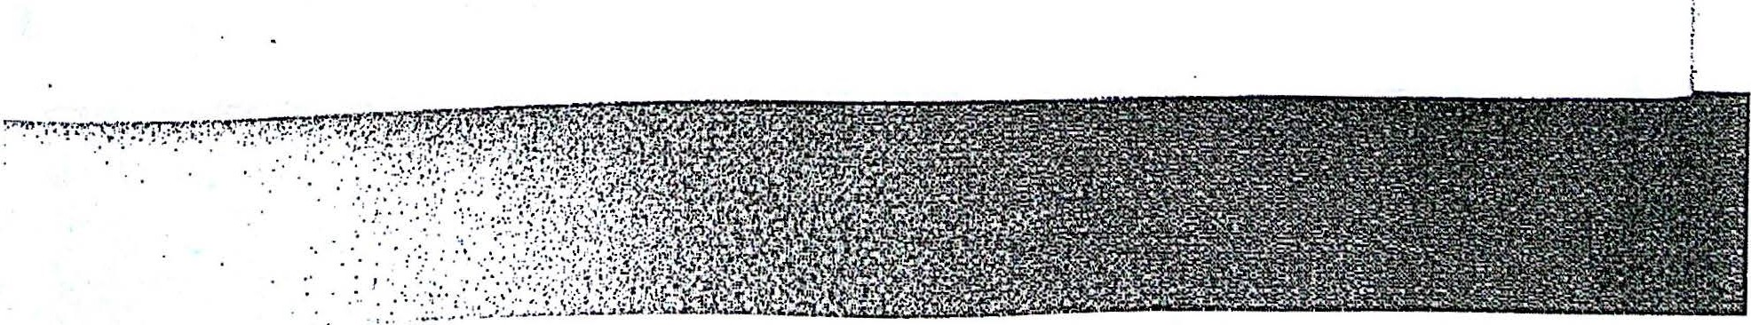

Scanned by CamScanner

I

*i*

*)*

*·1*'

 

Similarly, a process in BPMN is a sequence of activities leading from an initial state of the process instance to some defined end state. The start of a process is marked by a triggering event, such as receipt of a request. The *process model* is a map *of* all the possible paths - sequences of ac\-ivities - from that initiating event to any defined end state, success or exception. Like activity, a process is discrete not continuous. It is performed repeatedly in the course of business, and has a well-defined start and end. Each instance of the process follows some path in the process model from start to end;



Like activity, BP1vIN's definition of a process is sometimes at odds with the term "process" as used by BPM or enterprise architects. l or example, enterprise BPM often refers to *business process frameworks,* such as SCOR, ITIL, or cTOM, that enumerate the major processes and

activities for a particular industry, typically for cross-company benchmarking 8. One

organization, called APQC, publishes a cross-industry Process Classification Framework9,a hierarchy consisting of Categories, Process Groups, Processes, and Activities. Unfortunately,

very few of the processes and activities listed in the PCF match BPMN's notion of process and activity. Most are of the *Manage* X variety, ongoing business functions rather actions on discrete instances with well-defined start and end.

For example, below is a brief excerpt from the PCF for the process called *Process Expense*

*Reimbursements 10*

*•*

represent activities.

Here three-digit headings represent processes and four-digit hendings

* + 1. Process expense reimbursements (10757)
       1. Establish and communicate expense reimbursement policies and approval limits (10880)
       2. Capture and report relevant tax data (10881)

8.6.2.3 Approve reimbursements and advances (10882)

8.6.2.4 Process reimbursements and advances (10883)

8.6.2.S Manage personal accounts (10884)

Within a process, activity instances need *to* align with each other and align with the process instance as well. If we interpret 8.6.2 as the BPMN process of handling employee expense report"S, that is certainly not the case here. The first activity is really two separate BPMN activities, since establishing the policies and communicating them probably occur at different times and frequencies. Also,neither one of them is part of this process. The second activity is

S See, £or example, Paul Harmon, J3usiness Process 2nd edition, Morgan Kauffman, 2007.

1. [http://www](http://www/) apqc.org/process-classification-framework
2. http:[//www.apqc.org/knowledge-](http://www.apqc.org/knowledge-)

base/do\vnload/31928/a%3Al%3A%7Bi%3Al %3Bs%3Aloo/ 3A%222%22%38%70/PCF_Cross%20Ind

ustry_v5%202%200.pdf?destination=-node/31928

. *fL*

Chapter 2. How Does a Model Mean? I 11

,.,

*·:*



'



I -

**Scanned by CamScanner**

also two BPMN activities. Tax data might be captured *with* each expense report, but reporting it to the government would be done quarterly or nnnually . The next two could possibly be BPMN activities in this process, assuming processing advances and reimbursements use the same process. The last one is an ongoing function, not a BPMN activity at all.

From BPMN's conceptual framework, a better activity list for processing employee expense reimbursements might be as follows, where an instance of each activity is a single expense report:

* + 1. Process expense reimbursements
       1. Review e><pense report and supporting docu mentation
       2. Approve reimbursement
       3. Capture tax data
       4. Issue payment

My intent here is not to pick on APQC, specifically. The problem is rampant in the literature of business architecture and enterprise BPM. I have come across situations where a BPM architecture team has defined a list of major "activities" that are not discrete actions performed repeatedly on instances with well-defined start and end points, and has then tasked process modelers vvith wiring them together to desc1ibe end-to-€11d processes. But it is impossible.



**Process Logic**

When a process modeler begins to document an as-is, or current-state, process, the procedure typically involves meeting with the poople directly involved with the process, so-called subject matter experts. And the SMEs might be inclined to describe the process like this: *First X happens, arul then it typically goes to Y, and then finally we do* Z. 1liat's fine. It describes what *usually* happens, leading to a successful end state. Or maybe that's just how it happened in one recent instance.

But the process model is more than documentation of one instance of the process. It is a complete map of all the paths from the triggering event to any defined end state. That does not mean every conceivable possibility, no matter how remote, only those end states and paths·that occur with significant frequency.

So the first questions for the SME should be things like this:

*·How does the process actually start? What event triggers it? Is there more thl411 one poss fble*

*way it could start?*

. *'What determines when the process is complete? Are there different end states for the process, such as one signifYing successful completion and others signifying failed* or *abandoned attempts?*

*How does the process get from X to Y? Does the person doing Y somehow just "know" it.'s*

*supposed to happen? You said it "tljpically" goes to Y,but where else might it go? And wlnj?*

12 I Chapter 2. How Does a Model Mean?

__ **_ _...,.**

**.,....,,,...,,---------------•:dtaiRHul**

Scanned by CamScanner



I.:.i

I

';

i

*How do you know when X* is *done? Does* X *always end in the same way? Or besides the*

*normal end states are tJzere exception end states where you don't go on to Y? Are there ntlcs*

)

';

t

*that govern this?*

!

i

.Answers to these questions define the *process logic.* The process logic defines an possible i

sequences of activities from the process's initiating event to one of its end states. Each activity is represented in the diagram by a rounded rectangle, and solid arrow connectors called *sequenceflows* describe the possible flow paths. There may be brand\ points in the flow, where an instance could take one path or another based on some condition. There is a diamond

shape in J3PMN for that, called a *gateway,* and the labels on the gateway and its outgoing · j

connectors show that conditional logic on the process diagram. BPMN also has circle shapes,

.

i

calJed *events,* that can divert the flow when some exception occurs or some external message i

i

arrives. In fact, all of the process logic in BPMN is composed of just these three primary *flow nodes* - activities, gateways, and events - and the sequence flows connecting them. Each end of a sequence flow must connect to an activity, gateway, or event.

TI1e SME's first reaction to these questions might be, "Nothing is *making* the process go from X to Y. That's just what happen." Of course, something is *always* making it go.The logic is just hidden, probably inside the head of whoever happens to be doing X for that particular instance. And there is tremendous value in surfacing that logic, making it explicit in a diagram that all stakeholders in the process can understand . Without that, you can't really *manage* the process or improve its performance.



**Orchestration**

BP:MN' only describes processes in which the process logic ...:. the map of all possible paths from triggering event to one of the process's end states - is *explicit,* defined in advance of the triggering event. BPMN is a language for specifying that explicit process logic. Every instance of the process must follow some path inthe process model. BPMN's teclmical term for such a process is an *orchestration.* In the BPMN 2.0 specification, the terms *process mod.el* and *orchestration model* mean the same thing.

It is reasonable to ask, *HHow can the process logic be defined in advance wften an Approval* is *completely arbitrary?"* Ahh, but how the performer decides to approve or reject is not part of the *process logic.* It is part of the internal *task logic* of the .Approval step. For most activity types, BPMN does not describe the task logic, only the process logic,. the logic of *w1zat happens next w1um the task is complete.* The process logic says, "lf Approval ends in the state *approved,*

follow..thls pth; if it ends inthe state *rejected,* take this other path." So orchestration does not

mean you know in advance the particular path an instance is going to take, only that the

*conditions* for taking any possible path in the model are known in advance.

In contrast, a purely *ad-hoe process* is not an orchestration. By ad-hoe, I mean a process in which the performer of each task determines the task to perform next, and the list of possible next tasks is wide open, not enumerated in the model (If the list could be enumerated in advance, you could just show them all in the diagram, and let the task end state determine which path . to follow. Some so-called ad-hoe processes are like this, in fact. BPMN is not a

Chapter 2. How Does a Model Mean? I 13

I

I

I

I

Il .

**Scanned by CamScanner**

--""

-- -- _-:::-_..

-· --- .

-----

--=-- . -:....

*·-- ;:*



:::_: -:::._ :_---=..".G--- ==::..

. b havior but because the resulting good fit for them, not because it cannot deswbe the e dling effort.)

diagram would be difficult to understand and not worth the mo .

. . *,r. ation* accumulated.by the mstance

The path taken by any process instance depends on *m1orm* d oduced in process

as .

progresses. That

. . ·

messages received' . ata pr

mes that all this

it infonnat1on includes

. . 1y assu

activities, and the end stntes of completed . . . BPMN unpliot. h ocess model

ac:t1v1ties.

. . . I . W"th this information, t *e* pr

instance data 1s available to the process og1c. *1* y · ht even " , . . . . to go next. ou nug knows," as each step is completed, where the mtance is gomg t t step

think of the process model as an m. telh·gent force that "gu.i·cles" the ins·tance Crom s ep 0

h

th •

It i.s a very short leap from there to an actual process engm. e m·

a BPM Su.ite· Even t11oug e

vast ma1.on.ty of BPMN models do not descn.bc automated processes, BPMN treats the process

as if it could, in principle, be automated. This helps explain why it is so importnt that instances of each process activity are aligned with each other and with the process mstance itself.

Remember that BP.MN originated as a graphical design language for automated process flo"':'· In most processes modeled in DPMN, the process logic is not automated ... but DPMN treats it ac; if it could be.

*The Questions BPMN Asks*

Inmy BPMN training, a student once asked me how to show in the diagram that a certain

activity normally completes infive hours.I replied that that is not a question that BPM.i"\J asks. Instead, BPMN wants you to say *what action occurs if the activity* is *not completed infive hours?*

Do you send a reminder? Notify the manager? Escalate the task? Cancel and abandon the process as a whole? TI1ose are things that BPMN describes. They are part of the process logic; the average time to complete isnot.



*A* BPMN process model reveals only the *order* of activities, *when* they happen, and under what conditions. It describes what happens next when an activity completes, but may have little to say about what happens inside the activity itself. It does not describe *how* an activity is performed or *where* or *why.* In fact, BP.MN barely touches on *.what* the activity is or *who* performs it. Those are simply suggested by labels on activities and swimlanes in the diagram. In fact, BPMN has been criticized for omitting this information from process models... often by the same vendors and consultants who complain that the BPMN notation is too complex! It's not thnt those other questions are unimportant, but they are not part of the process logic, . and thus remain outside the domain of BPMN.

It is important to keep in mind that, as a multi-vendor standard, BP.t..IN is a negotiated agreement among many competing interests. In order to get anything at all through the committees, its scope is narrow by necessity. Many BPMN tools do include,in fact, models of organizational roles and groups, problems and goals, simulation parameters, KPis, and the like, but these models are tool-specific. The only process information desc1ibed uniformly across tools is the BPMN process logic.

14 I Chapter 2. How Does a Model Mean?



'"Scanned by CamScanner------

::;;

·-

3



i

I



I

BPMN Levels and Process Modeling Conformance Subclasses l

\

t I have been conducting BPMN training since early 2007. I can say from experience that not ! everyone who 'i·vants to learn BPMi'.\f ls interested in the same level of process detail. While i the language excels at expressing exception handling and other event-triggered behavior, to j

.

\

!

some modelers that is just extraneous clutter; they don't care about it. And they don't see the l

need for nll the subtypes of activities, gateways, and events in the full BPMN element set. In !

fact, only a small fraction of the full element set is commonly used.

Thus, my training always started out by restricting models to a limited working set of the shapes and symbols that we called the BPMN *1-evel 1* palette. Day 1was, and remains, Level 1 only. Business users easily tmderstand it, and it makes learning the basks of BPMN easier. Moreover, it is a palette that almost every DPMN tool supports. The Level 1 palette is essentially the shapes and symbols carried over from tra ditional flowcharting, and it is sufficient for desaibing most process bchavior in a compact business-friendly way. In fact, if you are willing to ignore behavior triggered by timeouts nnd the arrival of external messages,

it may be all the BPMN you ever need.

On Day 2 of the training, we move on to exception handling, with emphasis on Message, Timer, and Error events, plus some additional branching and merging patterns. This requires a slightly larger palette we call *BPM N Level* 2. Since event-triggered behavior is a fact of life in real-world processes, business analysts who want to use BPMN for defining solution requirements need to learn BPMN Level 2. Even though the BPMN Level 2 palette encompasses only about half of the full BPMN 2.0 working set, many BPM.i'l tools still don't support all of it.

Both Level 1and Level 2 concern *non-executable processes* and rely solely on information visible in the diagram. *Executable BPMN,* in contrast, *is* all about the XML details that are *not* displayed in the diagram, like data models, conditional data expressions at gateways, and detailed task assignment logic. I call it *BPM N level 3;* as of this writing, it is still not part of the training. Both Level 1and Level 2 omit these details. Not only are they not represented in the diagram, but until BPiv!N 2.0 there was no standard X\!11. representation for them.

Consequently, their definition has always been tool-proprietary. Today, with 13PMN 2.0, you

j

can do Level 3, that is, define executable process logic using the XML elements defined in the

BPMN standard. But tools that do that are just now getting off the ground. As of this writing, just a few have the basies of Level 3 working, and none yet include all of the elements of the Level.2. p. a.l.e. tte. *We*will discuss Level 3, or Executable BPMN, in Part V of this book.

,.

Thus BPMN levels originated as a pedagogical strategy inmy BPMN training. Even though they were not part of the BPMN pecification at the time, OMG included my explanation of the levels as "reference material" for its OCEB BPM certification exam. But it turns out that levels have a second value, important to tool vendors: By limiti11g the palette of supported shapes, they make model interchange possible. In the end, that is what led to their inclusion in the final BPMN 2.0 specification!

l

I

i

)

i.

I

i

}.

i·

f,

1:

l"'

t.

1:.

*ii*

*·-*

t·:

[·

f.



*f*

.

*J*

i.

ecification draf t said t}iat in '

*ioo*

When I left the BPMN 2.0 technical committee in June, *9,* the sp art the entire set of BPMN

order to claim Process Modelincr Conformance, a tool had to supp d . tool it

1

o .bl for a pure mo e mg ' . process model shapes and symbols. Vvhile that might be possi e . p n· al BPMN

was never going to allow interchancre with tools used for executable design. rac c t f

.

. *n* t . f ng the workmg se o mteroperability between tools demands, first and foremost, res nc 1 . • t .t

1

shapes and symbols. If a tool vendor could limit import/export to the Level 1workwg se '

would be far easier for that.tool to interoperate with others.

Even though model interchange was always an explicit goal of BP.MN 2.0, the .vendors in charge of the spec drafting process were reluctant *to* commit to a real test of comphance. *As* a member of the technical committee, I tried very hard to get the levels included in the Conformance section of the June 2009 beta specification, but without success. Bu t Robert Shapiro managed to push them through in the Finalization phase, and they are now officially part of the BPMN 2.0 final specification!

In the spec,Level 1is called the *Descriptive Process Modeling Conformance subclass,* and Level 2

. is called the *Analytic Process Modeling Conformance subclass.* A few BP:MN elements switched

_levels, so if you compare the current edition of this book with the original you will see some minor changes in the palettes. In this edition, the Level 1palette has been adjusted to match the official Descriptive subclass exactly, and the Level 2 palette matches the official Analytic subclass. There is also a third subclass, called the *Common Executable Process Modeling Conformance subclass.* We'll talk about that one inChapter 19.



In the specification, members of each subclass are defined in terms of specific XMI. elements *:* and attributes. You should not be surprised that those elements and attributes represent only I ! the information visible inthe diagram: the element type and its icons,markers, border styles,

I

and labels - plus the unique ids and id references needed to hold the model structure together. All the details needed to make the process executable -definitions of data, gateway conditions, messages, services, and task assignment - are outside of the Descriptive and

Analytic subclasses. *i*

I believe *this* reinforces the basic premise of the Method·and Style Dpproach: *For non­* i

'

*executable process models, it's the notation* - *what you see in the diagram* - *that really matters.* iI

l

Another way of saying it is this: *If* it's *not in the diagram it doesn't count.* Method and Style I

!

shows you how to convey ns much meaning as possible from the BPMN shapes, symbols, nd I

labels alone. To achieve that, Method and Style obeys the niles of the BPMN 2.0 specification

. .but imposes additional conventions on the modeler to ensure the diagram's meaning is unambiguous ..

The second half of this book, the BPMN Implementer's Guide, shows tool vendors and developers how to translate that meaning, as reflected by the diagram, into XML that can be imported and understood by any tool supporting the Analytic subclass. If a given diagram has one and only one serialization, then interchange of that model between tools becomes straightforward and automatic.

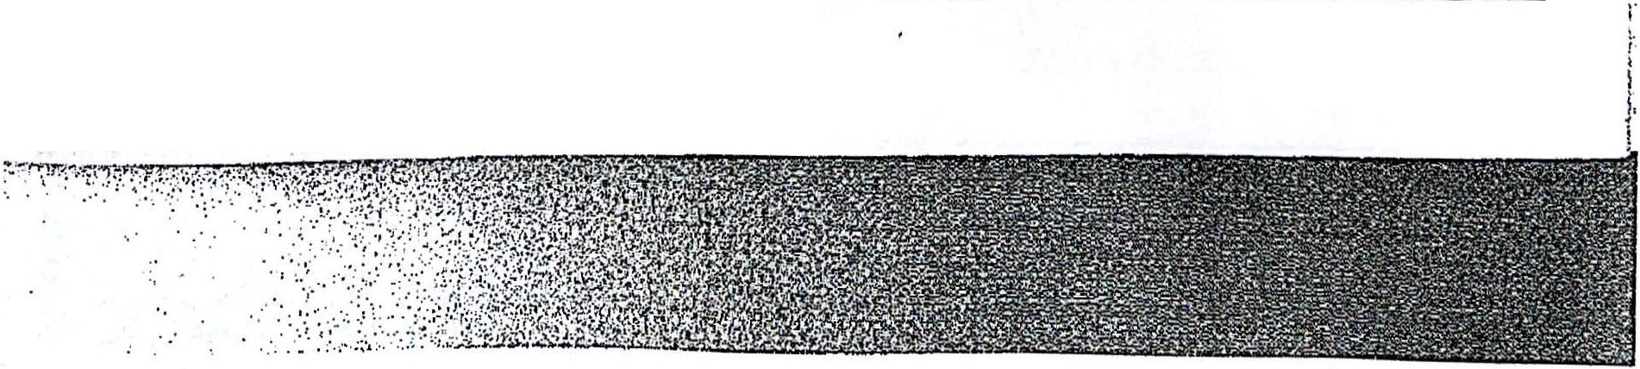

16 I Chapter 2. How Does a Model Mean?

**Scanned by CamScanner**



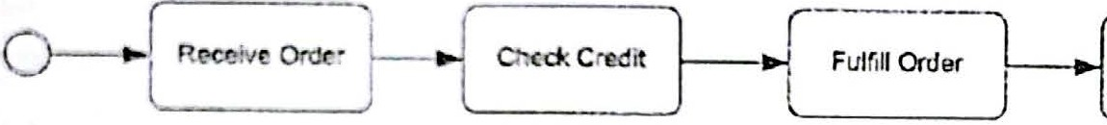

CHAPTER 3

BPMN by Exa mple

A Simple Order Process

on;1d!'r l hJ:> proce,;s to hand le an order. TI1e rom pJ ny receives the order, checks the buyer's

cr dit. f-u lf1ll<. t h o:-drr, .1n<l Fends an invoice. ln simplest tenns, that looks like this in BPMN:

flgure 3·1. Basir ord rr proces..<;

l11c thin circle at the sart of the process is called a *start event.* It indicates where the process i!l.;trta. 'Jl'lc thick cirde :J the end is called an em/ *event,* signifying the process is complete. The rounded rcctngk!i :i.rc *i:ctiviti.* An ;:ictivity like *Check Credit* represents an *action,* a specific

unit or work perfonned., as distir.ct from a *function* (e.g., *Credit Check)* or a *state* (e.g., *Credit*

*Ok).* To rinforcc 11is. activities should have names of the form VERB-NOUN. An element's

*M m"* in the Xl'v1L is dlspl3yed as tl:e *labd* of the shape in the diagram.

Exceptions and End States

nus diagrcm does not yet represent a process model It is just a simple description of the *happy pa:r..* the noIT!'lnl uem:e of activities when no exceptions occur. What exceptions could oo:ur. Well, the buyer's cred it might not be sufficient, or the goods might not be in

!lt:O<.' k ·Those·sih.rntion would rep:esent failed orders. So a more complete model of the

proress misht loo.1.- like this::

19

rI -- ---rr --a"o"'""



e. '""o"" L.A ... l ""'"' "" }O·r-detC0CIT'Cl!lle

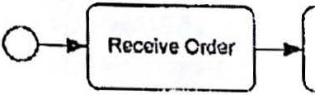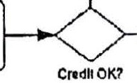

Check Credit

M

'- --' ln tod<? ··

Figure 3-2. Order process l'¥ith exception paths

The diamond shapes are called *gateways.* 'Ibey represent branch points in the flow. *BPM N* provides a number of different gateway types, but this one - the *exclusive data-based gateway* (also called *XOR gateway),* a diamond with no symbol inside - means take one path or the other based o.n some data condition, such as Is *the buyer's credit OK?* or *Are the order items in. stock?* The diagram communicates the process logic by the combination of the gateway label and labels on the sequence flows out of the gateway, called *gates.* Gateways are a common way of splitting *exception paths* from the happy path.

Note we now have n.vo end events, one labeled *Order failed* and the other *Order complete.* BPMN docs not require multiple end events like this, but a Method and Style principle requires using separate end events to indicate distinct *en.d states,* such as one representing' success and the other failure,and labeling each with the name of the end state.

Also notice that the diagram now describes three distinct paths from beginning to end. Not all of the model's activities are performed for every instance of the process. If the credit check fails, for example, we do not fulfil( the order. If the order items are not in stock, we do not

send the invoice. This is common sense,and the

'

BPMN

diagram indicates this explicitly.

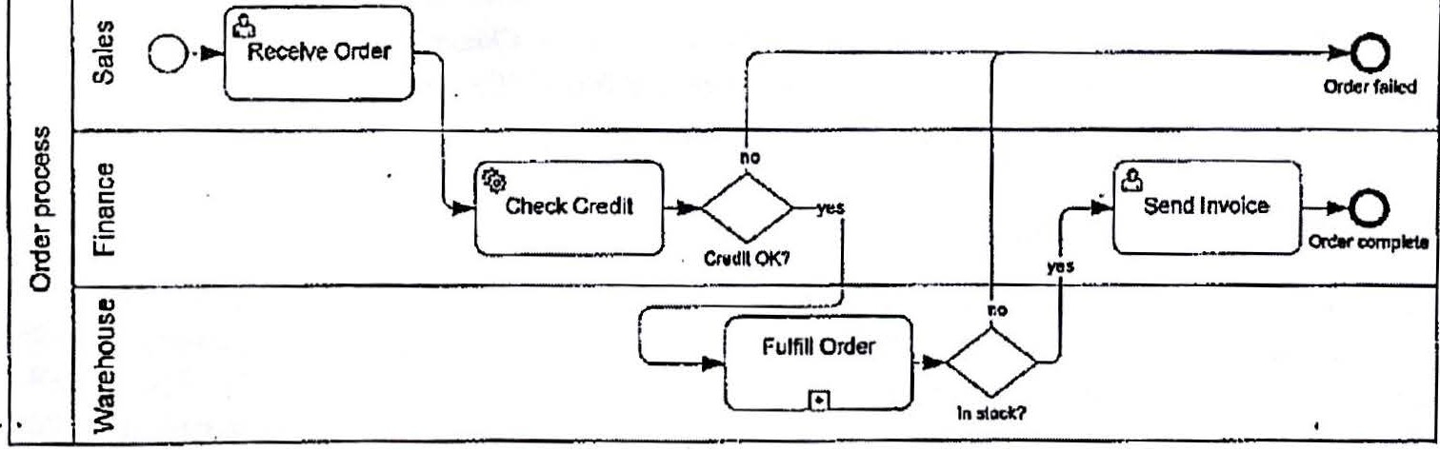

Figure 3-3.Order process inswimlanes

**Swimlanes and Activity Types**

BPMN also lets us indicate the performer of each activity, using *switrllanes,* or to use the BPMN term, *lanes* {Figure 3-3). Lanes usually represent roles or organizational units that perform activities in the process. They are drawn as subdivisions of the rectangle containing the process, called a *pool.* You sometimes see pools labeled with the name of an organization,

20 I Chapter 3. BPMN by Example



Scanned by CamS,ccanffinffier=-- ===========------=::=:===== llliiiiiiii:iiiii...._..liiiiii.i F·· ==R



but for pools that contrun activity flows -some don't, as we will sec later _ it's best practice to label them with the name of the process.



We can also indicate the *type of activity* through icons and markers inside the rounded rectangle. It is generally useful to distinguish human tasks from automated ones, and these are indicated in the diagram by different *task type icons.* In Figure 3-3, *Receive order* and *Send invoice* are human tasks, called *User tasks* in BPMN. *Check credit* is an automated task, ea.lied a *Service task* in BP:MN. Automated means executed with no human intervention . If a person

pushes a button once and the rest of the task is automated, that is a User task, not a Service task.

Lanes really apply only to User tasks; we can place gateways and events in whatever lane is convenent. Some people like to put Service tasks in their own lanes as well, either one lane

for alJ systems or one lane per system. I tend not to do that, but it's a matter of personal , preference.

**Subprocesses**

What type of activity is *Fulfill Order?* [t docs not have an icon. representing a human or automated tnsk, but a little [+) marker instead. That is a *sub-process,* one of BP:tvlN's most

•• jmportant concepts. A subproccss is an activity containing subparts that can be expressed as a

process flow. Incontrast, a *task* is an activity with no defined subparts.

A subprocess is simultaneously an *activity,* a step in a process that perfom1s work, and a

*process,* a flow of activities from a start event to one or more end events. In the diagram, a

J subprocess can be rendered either *collapsed,* as a single activity shape, or *expanded* as a process diagram in its o;vn right. BPMN tools typically let you toggle or hyperlink between those two views, allowing zoom in and out to view the process diagram at any level of detail.

One way to represent the expanded view of a subprocess is *inline* in the diagram, as in Figure 3-4. With inline expansion, the process flow is enclosed in an *expanded sitbprocess shap e* (a resizable rounded rectangle). Figure 3-3 and Figure 3-4 mean exactly the same thing, but Figure 3-4 provides an additional ]evel of detail. Note that the expanded view of *Fulfill Order* looks just like a process. It has a start event, a flow of activities, and an end event for each distinct end state. The start of the *Fulfill Order* process is triggered by the sequence flow into the subprocess, which, we can see from the diagram, occurs after *Check Credit* whenever the credit is OK. When the sequence flow arrives at *Fulfill Order,* it continues immediately from the start event of the expansion. When *Fulfil! Order* completes, the process immediately continues on the sequence flow out of the subprocess.



In Figure 3-4 we also see the benefit of using multiple end events to distinguish end states, in this case the *Out of stock* end state and the *Tn stock* end state. By matching the label of the gateway following the subprocess *(In stock?),* it is clear the gateway is asking the question, "Did we reach the *In stock* end event?" Matching the label of a subprocess end state with the label of a gateway immediately following the subprocess is an important Method and Style convention.

Chapter 3. BPMN by Example I 21

-,.



**80&111 met 8y Gtu Geel'ill'il eP**

c



"'

al

iQ

0

§

ns

.u&.:

[ReeeNa :1

---- ·

Order fa1. ecl

rJ)

*M*

*·*

*.*

II)

..

L_-

··

Cl-

-e

0

Fl.MiR Order

---

gi

-2

k>

....

}.{

**-0**

Oulohlodl

l

yu I

eclcStock

ShipOrdu

}-;2

lnot:cic7

----

Figure 3-4. Order process including expanded subprocess

**Process Levels and the Hierarchical Style**

Tlie process depicted inside the *Fulfill Order* activity in Figure 3-4 represents a *child process fovel* with respect to the level including the overall process start and end and the *Ful.fill Order* subprocess, shown in Fgure 3-3. TI1e child level could itself contain subprocesses, and there is no limit to the number of levels you can nest in this way.

lnline expansion, as in Figure 3-4, depicts the parent and child levels in the same diagram,but it is not the only way to render the child-level detail. In fact, with most tools, except insimple cases, it is rarely the best way.Note that Figure 3-4 takes up a lot more space on the page than Figure 3-3. For end-to-end processes, showing all the subprocess details on a single page usually isn't possible. One solution is to use *off-page connectors* to link to a continuation of the process level on another diagram. BP.MN provides a notation for this, called a *Link event pair.*

But I recommend a different way:depicting the duld-level expansion in a separate diagram. I call it *hierarchical expansion,* because it expresses the end-to-end process as a hierarchy of diagrams. In the tool, the parent and child-level diagrams are *1typerlin.ked* together, but we

- ···cannot rely on hyperlinks when the model is printed to paper or pdf . Inthat case, we need to rely on *matching labels* to link the diagrams together. Let's see how it works, and then talk about why it's the preferred way.

i

j

.i

j

i.

I'

j

l

i

·l

\ j

,. ' J

.

;,..

'1.

,.

.

,.

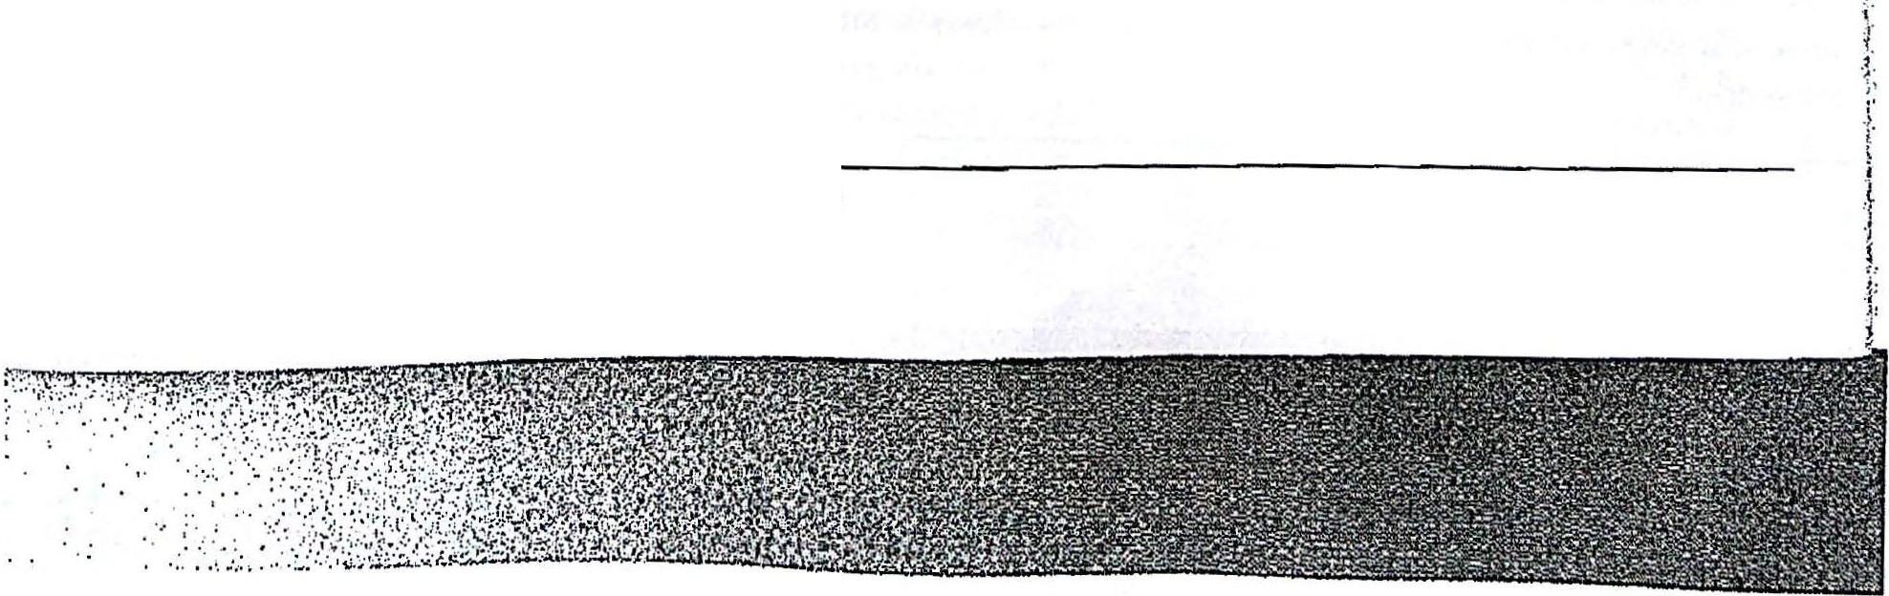

22 I Chapter 3. BPMN by Example

!S' 'Canned by **Ca111Sca11ner**

no

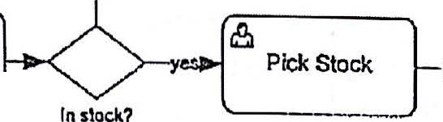

Check Slock

Q--

**--+Q**

Out ofslocll.



Figure 3-5. Subprocess expansion on a separate page

In stod\

Ship Order

Figure 3-5 shows the expansion of *Fu.Ifill Order* in the child-level diagram. Note that it omits the pool shape, which is inherited implicitly from the parent. Remember, this is not a new process but a subprocess of *Order Process.* The child-level diagram also omits the expanded subprocess shape surrounding the flow. *A* child-level expansion may contain lanes, although none are represented in Figure 3-5. If lanes are absent in the child level but present in the parent level, it is implied that activities in the child level inherit the lane of the collapsed subprocess in the parent level. But technically, lanes are defined independently at each process level.

'While inline expansion is useful in simple diagrams, in most casesIprefer the hierarchical style. One reason is it allows the top level of a complex process to be represented end-to-end on a single page. That top-level view provides little detail about each major step of the process, but it does reveal at a glance all the possible paths connecting those steps, the meaning of the· process instance, how the process starts, its possible end states, and its interactions with external entities. In other words, it expresses on a single page the "big picture" of the end-to-end process.

From the top-level diagram you can then driU down into each child-level subprocess and view its details in a separate linked diagram, which can in turn drill down further to a deeper child level, and so on. With hierarchical modeling, additional detail is provided in layers, and you can zoom in to view detail at any level without losing the integrity of a single end-to-end model. Even though the model is represented visually as separate pages, in the XML it is a single model. That is far better than maintaining separate high-level and detailed models, and keeping them insync as the process logic changes over time.

The hierarchical style does add a bit of complexity when viewing the diagrams, since parent and child levels appear on separate pages. For example, with inline expansion (Figure 3-4) the end event *In stock* and the gateway *In stock?* appear on the same page, while in the hierarchical style (Figure 3-3 and Figure 3-5) they appear on separdte pages. Once you get

used 'to·the.hierarchical style, mentally connecting the diagrams becomes easy.

111e duld-level diagram represents the activity flow *inside* the subprocess. One mistake beginners make is replicating, inside the child-level expansion, activities that occur either *before* the subprocess starts or *after* it ends. For example, Figure 3-6 is *incorrect* as a child-level expansion of *Fulfill Order:*

Chapter 3. BPMN by Example 23



**Scanned by CamScanner**

~~--~~



-- -·-no -- ---- -...()

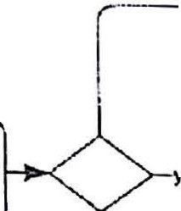

Out orstoc:.

0- Check Stock

f%

*·cs*

i;:: Pick Stock , {

Ship Order Sen·-dInvoice J.Qk

l11slock? l_._

'a

f igure 3-6. Incorrect expansion of *Fulfil! Order*

T_he) r_eas,on is *Send Jnvm*·*ce* i·s not part of the subproccss. In the parent leveJ diagram (Figure 3th3 :it c?t,ns after *Fu/fill Order* is complete. Modcling the chiJd level as in Figure 3-6 means c mvo1ce is sent nvi·ce, once w1·un.n *Fulfill Order* and then again afterward. That was not the

mod.eler's intent-

Remember., wl1cm tIle chi.ld. level i.s complete the flow 1. mmed1.ately

continues on the sequence flow out of the collapsed subproccss at the'parent level.

Taking ano.ther look at Fl'gute 3-vl, you mi•ght deci• de thnt simply ending the process when a requested item is out of stock i·s not thc, best w_ay t.o handle !:h.is excepti.on. Perhaps you would contac.t the customer and offer a. replacement i.tem, and i.f the customer accepts the offer, go on to ~~f~~u~~1~~£1ll the order. That would look something like this:

r ----- . ---- -·1

.. .. o{-·- *,-.----Q*

II)

! \.._ _ •• Acotl••I?

1:!

0

!!I

:"""""'l I . ['°........ •O

0.. c

.. I

~~..~~ '-·**YOI** - **'O**

##### ::::

*.*e*c.*

Ll fur.110. rtler '

- **kttibd.7**

Figure 3-7.Loopback to handle exceptions

In BPMN, unlike block languages such as BPEL, a sequence flow may freely loop back to a previous step. InFigure 3-7, if the replacement offer is accepted, a gateway directs the flow back to *Fulfil! Order.* Remember the process isnot complete until an end event is reached.

The BP.MN spec does not place any significance on whether a sequence flow enters an activity

·ti·om the left, right, top, or bottom, nor even whether pols and lanes run horizontally or

vertically. 'Ihese are really matters of personal style. I usually try to draw the flow left to right with sequence flows entering activities from the left and exiting from the right.It takes some rearranging to keep line crossings at a minimum, and sometimes that cannot be avoided. But keeping the diagram as neat and consistently organized as possible is important to the objective of shared underst<inding . Nothing *is* more frustrating than looking at a diagram someone else has created and being unsure where exactly the process starts and ends.

I 24

## I

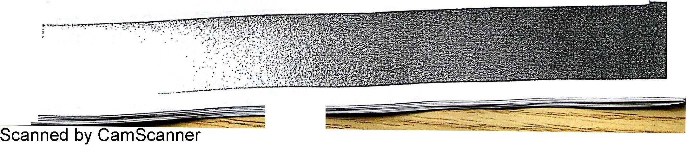

I Chapter 3. BPMN by Example

1-

L

l _ • • --·-- -..·- ----·--------

?



**Parallel Split and Join**

Nw let's consider oe last detail of our *Fulfill Order* subprocess. In order to expedite shlp1et, we'd like to make the shipping arrangements concurrently with picking the stock, that is, m parallel. We originally considered making these arrangements to be part of *Ship*



*Order,*but technically that means we don't do it until after *Pick Stock* completes.

**o**

**f** Out *ot*'1od<

no

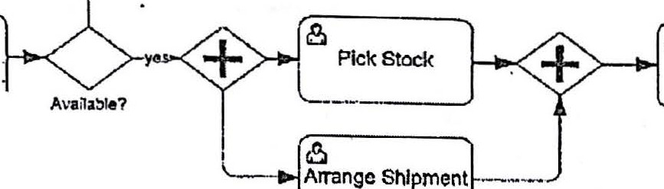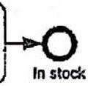

8

Ship Order

Chcck Stock

\, . _,,

Figure 3-8.Parallel split and join

Figure 3-8 shows how itlooks. Again it uses a gateway, in fact two of them, but th a symbol inside. A gateway with a + symbol inside is a *parallel gatcru;ny,* also called an *AN D-gateway.* A parallel gateway with one sequence flow in and two or more out is called a *parallel split* or *AND-split.* It means unconditionally split the flow into parallel, i.e., concurrent, segments. Both *Pick Stock* and *Arrange Shipme1tt* are enabled to start at the same time. If the same shipping clerk performs them both, they cannot literally be done simultaneously. Concurrent really means it does not matter which is done first.

We cannot combine this parallel gateway with the XOR gateway that precedes it *(Available? )* because they mean different things. The *Available?* gateway is an exclusive decision, meaning take one path or the other. *After* we take the *yes* path, then the AND-split says we do *Pick Stock* and *Arrange Shipment* inparallel.

The second parallel gateway, with multiple sequence flows in and one out, is called an *AND­ join* or *synchronizing join.* Itmeans wait for *all* of the incoming sequence flows to arrive before 'P.nabling the outgoing sequence flow. Inplain English, it means *Ship Order* ccUUlot occur until both *Pick Stock* and *An·ange Shipment* are complete.

Labels on AND-splits and joins (and sequence flows connecting them) add no new inform.a. ti.on... ,.so it is best. to omit them.

'

Unlike BPEL, BPMN does not require all the paths out of a parallel split to be merged in a downstream AN 0-join. They could even lead to separate end events.Inthat case, the process level is not complete until *all* parallel segments have reached an end event.

**Collaboration and Black..Box Pools**

*1*

I

J

*l*

..t·

t

I

;

f

i

;

<

.

*i*

*I .*



It is not uncommon for experienced flowcharters, new to BPMN, to make the Customer a lane

! ' inside the process, and start the process with tasks in that lane like *Fill ozd order form* and

Chapter 3. BPMN by Example I 25

s

I

**·scanned by CamScanner**

·'

*Submit order ...* but that would be incorrect. Actually, the Customer is *external* to the process,

not part of it. Think about an online store like Amazon.com. Have you ever pu t a book or ,,. some other item in your shopping cart but, in the end, decided not to o'rder it after all? Of

course you have! Now in that situation, have you created an instance of Amazon's order process? I think not. Amazon's order process starts when they receive the order, even though Amazon itself provides the shopping site. TI1e order process includes securing payment, retrieving the order items from the warehouse, and delivering them to the Customer.

This is a fundamental point, and we will discuss it further, but for now please just accept that the requester of a process is usually best rnodelecl as an *external participant,* not as a Jane inside the process pool.

We model nn extemal entity like the Customer as a separate *pool* in our diagram. But unlike the pool that contains the *Order Process,* the Customer pool is empty. It contains no flow le ts whatsoever. We call it a *black-box pool* - meaning Customer's internal process is mvi_sible to us. Technically, in the XML, a black-box pool represents a *particip ant* -an external business entity - that has no process. (It doesn't hterally mean U1at the Customer has no defined buying process, but that the Customer's intenal process logic is invisible to the Se.ller.) \'\'ltile we label a process pool with the name of a *process,* we label a black-box pool w1th the name of the *role* or *entitlj,* in this case *Customer* (Figure 3-9).

1 11

.

: *IS* ' 0

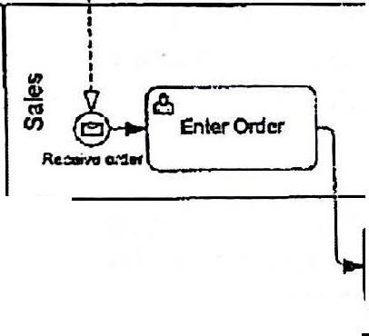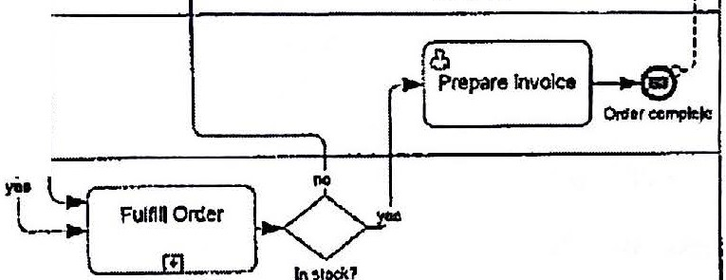

Cidor

:

1

---

ar1.,

:

.

**O:cr**

0

-

-

;

**u**

'

'

J

rre::;omenl

,

*'"-11'-*

**R• nc'1-2**

.

.

I

'

:

.

'

I

I

0

I

I

*:*

.

'

I

-0

0«Jer rtiltd

i

::!

"'

0..

I

I

I I

I

8c:

Check Credi!

t!

0

u:

...,,

.6c:

'c":

*...*

*_._J* Ctt410K7

Figure 3-9. Order process in collaboration diagram

The Customer (like other external participants) interacts with the process by exchanging messages. In BPMN, the term *message* means any communication between the process and an external participant. We can indicate these communications in the diagram with another type of connector, called a *message flow .* A sequence flow is represented by a solid line connector and can only be drawn *withiti a pool;* a message flow, a dashed line with an unfilled arrowhead and little circle on the tail, can only be drawn *between two pools.*

26

I chapter 3. BPMN by Example

I

In BPMN 2.0, Figure 3-9 is called a *collaboration. diagram.* In addition to the activity flow of our internal *Order Process,* it shows the interaction of our process with external participants by means of message flows. Note that the message flows attach to the boundary of the blackbox pool and directly to activities and events in the process pool.



The envelope icon inside the start and end events indicate that these events receive and send messages. In BPMN terminology, the start event has a Message *trigger,* and the end event has a Message *res11lt.* A *Message start event* has special meaning in BPMN, and we will see it again and again. It signifies that a new *instance* of the process is created upon receipt of a message, in this case *Order.* If a second *Order* message arrives immediately after the first, it creates a second instance of this process. You can only have a Message start event in a top-level process; a subprocess must have a *None start event,* meaning no trigger icon.

A *MesSt1ge end event* signifies that the process sends a message when the end event is reached. In BPiv!N, the black event icons mean the process *sends* a signal, in this case a message; a white event icon means the process *receives* the signal. Here the process sends an *Invoice*

message on reaching the *OrcJer complete* end state, and sends a *Failure notice* on reaching *Order faile* ·

Now, since it is the Message start event that is "receiving" the order, we will rename the first User task *Enter order.* Similarly, since the end event is now sending the invoice, we will rename the User task *Prepare invoice.* We don't want to duplicate the action of a Message event with an activity that does the same thing.

Finally, we see message flows out of and into the human task *Offer replacement item.* A message flow signifies any communication between the process and external participants - a phone call, fax, or paper mail. Activities can send and receive message flows just as events can.

As we said at the start of this section, the idea that the Customer in figure 3-9 is not part of the process, but external to it, is a surprise to many experienced flowcharters. But actually, this idea goes all the way back to the Rummler-Brache diagrams of the 1980s, what business people today call swimlane ·diagrams. Geary Rummler was one of the first analysts of business performance from a process perspective and a great influence on the management discipline of BPM. Paul Harmon, editor of BPTrends and a former colle<:1gue of Rumrnler's, · . recolUlts11:

*An IBM researcher took Rummler's courses and was so impressed with the pawl?' of*

·*Rummler-Brache diagrams that he created an IBM process methodology calletl LOVEM. The acronym stood for Line of Vision Enterprise Methodology. 'Ihe "line", in this case, referred to the swimlane line at thP. top of a Rummler-Brache diagram that divided the customerfrom the process and allowed the analyst to see exactly how the process interacted with the customer.*





i'

I

••

'./

'\

l

iiPaul Harmon, BPTrends Advisor, December *B,* 2008, [http://www.bptrends. com/publicationfiles/advisor20081](http://www.bptrends.com/publicationfiles/advisor20081) 209.pdf



·Scanned by CamScanner

Chapter 3. BPMN by Example I 27



. . ion of a process with its "customer." Inherent in analysis of process performance 15 the internet was drav.rn in the top

e

Jn Rummler-Brache and

. . lik den.vattves

LOVEM*/*

the customer .

t er's perspective on the

swimlane, and com munications across that line represented the cus om temal participan t.c; in

process. ln BPMN, the notation has changed slightly - we show ex separate pools -but the concept remains the same.

The same modelers who initially want to make Customer a 1ane . .de the process often insist

msi Th *t* ·5

1

on inserting activities like *Fill out orderform* or *Submit order* inside the Customer pdoofi. .t. a Ja.

not only unnecessary but incorrect. A pool contam· m• g

f1ow eIements is' by e ru ion,

process pool, not black-box. As such, it has to represent a *comp 1ete* process from start *to* end.

So i.f you put an end event after *Submi*.*t arder,* how

do you rece1·ve the replacement offer,

rejection notice, or invoice? You cannot draw those message flows to the boundary of a process pool, only to the boundary of a black-box pool. To draw those message flows you would be forced to draw a complete buyer process for the Customer. But ifyou are the seller, do you even know the buyer'sprocess? Probably not.

In my BPMN training, I normally leave the wscussion there.. But technically, BPMN 2.0 does define something called a *public process* (in BPMN 1.2 it was called an *abstract process ).* A public process lies in between a black-box pool (no process) and a_ fully defined process (called a *private process). A public process contains only activities that send ·ar receive messages; a*11 other activities are omitted. The intent is to represent the kind of message interactions defined in B2B standards like Rosetta.Net or cbXML. There the buyer and seller do not know the full details of each other's process logic, but the allowed types and sequences of message exchanges -like quotes,orders, confirmations, ship notices,and: invoices -may be established in advance through industry standards and trading partner agreements. That rarely applies in BPMN coUaboration diagrams, so except when the interaction is based on a defined B2B exchange pattern, you should simply use a black-box pool, not a public process, to represent the requester.



**Start Events and. the Process Instance**

111.e Message start event in Figure 3-9 is·significant in another way. A Message start event indites that the process starts upon recejpt of a *request.* Here the request takes the form of an order, but a loan application, an insurance claim, or customer service request are all examples of requests issued to a process provider. I recommend labeling Message start event

. .. *ceive [name of message],* such as *Receive Order.* Not all processes arc triggered by a request, but most are. A Message start event always signifies a processstarted by an external request, and the pool - usually black-box - at the tail of the message flow identifies the requester, in this case *Customer.*

A Message start event also signifies that the *process instance* represents the fulfillment of that single request That in tum implies that each activity in the process is just related to that one request as well. In particular, it may not describe the fulf:illment of other requests for the same process, such as another order. This is an extremely important point, and we will return to it inChapter 8.



28 I Chapter 3.BPMN by Example

,*(* ,

*J*

"

Scanned by CamSa· **mrrer--------=---!!!!l!!O!!!!! === ===========:Jl**

- .::. -·--



A Message start event always signifies that the process is started by *extemal* request, even when the requester is not a customer. It could be, for example, another internal process. Employee-facing processes are a gray area. Is the Employee external or internal to the process? It depends. Sometimes it is better to model the Employee as an external black-box pool, and other times better to make Employee a lane inside the process pool. Here are some guidelines, or rules of thumb, about modeling the requester.

* 1. If the process starts upon receipt of a form or other document and either



* + 1. the requester has no further interaction with the process other than receiving some form of final result or status notice, or
    2. the requester has occasional intermediate interactions with the process on an exception basis, but has no predefined process tasks to perform,

then model the requester as an *external black-box pool* sending a message flow to the process's Message start event.

* 1. If the requester has defined tasks to perform as a normal part of the process, model the requester as a *lane* within the process pool, and use a None start event (no trigger) for the process. There is no black-box pool for the requester in this case.

In Figure 3-10, the requester is external. Even though there are intermediate interactions with the process,they me on an exception basis.

## l

i

j

1

:;

.!

·j

!

"'

/..

·l

.

'

*y f>*



I

'\

I I I



I

I I I

I

I I I

I

I I I

I Missmg' Info

I I

Mi Info

I ssing !

I

Clim

request

I I I

response Confirmat:on

I I I

j



'

I I

I

Process claim

f/)

E

Receive

'Ri claim

*()*

+ Clelm complete

Figure :;-10: xtemal participant as black-box pool

. I F'g re 3-11 the Employee has specific tasks to perform in the process, preang the n 1··uti n and' justifi.cation documents, securing mana·gemen t approvaJ., and venfymg the

:e 1s e t is in working order when it arrives. Normally in this case you would use a *None*

*srl ent,* as shown here, signifying manual start by a task performer.

Chapter 3. BPMN by Example I 29

|  |  |  |  |  |
| --- | --- | --- | --- | --- |
| (/) | Oi_(Prepare docs and | | | --0 |
| i::::  .o  :!ii |
| a.  wE | El | .. |  |
| ;::>  g |
| E | Cl | | |
| 1!i | -c:  ro  "§  ::I  0. | L{p:me"nt  f!L_. 1 | | |
| ·a. |
|  |
| u |

Figure 3-11.Initiation by an internal task performer



,t..."""'

But if your focus is on what happens . . he 1:> ure-to-Pay process, you could

m Purchasing, t

roe

1. ust as easi.ly make the Employee an external poo1 here, as ·m r.1,1·gure 3-12· In that case the

Employee is just another external requster. It's all a mDtter of perspective.

Iii y *Ii* y

,....-'

I

:

ApprO\/Cd 'requisition

- I

1

I

Verillc':aUon

""l';'est

I I I

Verikation

resonH

>. (/) I ,I

ra

Cl;

O­

<ll

0::

1

I •

*')_* fPurc-hase -..

Receive and I .

.E C!.l

I Q)

(\) >.

.8... 0

... 0.

a.. wE

)-....! equipment

Rrceiva

req

I

Order

I

I

I

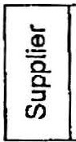

*'ii*

verify shipment 1-11>-j Pay m_volce

El *)* L _.....'.-'-_,,,,_,

? '•

lnvOlce Pa nt

I I

I I

-....()

Req oomplele



_ __· -

Figure 3-12. Another perspective on the Employee purchase requisition

**The Top-Level Diagram**



Let's take another look at what we have created so far in our Order process (Figure 3-13). At

this point, we have a fairly complete top-level BPMN diagram . In this diagram, the details of *Fulfill Order* are hidden, but we can drill down to see the child-level expansion in a separate hyperlinked diagram.

30 I Chapter 3. BPMN by Example

1 11

'I

ci.J.,

6: *B* . ? 6

I

**r *Qlt( t ·* 1t1i1:ed!a:""°'ioit**

- r-·---

|  |  |  |
| --- | --- | --- |
| ..  "Q)'  u  "'E! | Ill  8  "tl*) Ent!r Ord!r |  |
| I)  u  c:  II)  c  u: | |
| IsI)  *.i::;*  !l)  i;;  -3: -------- | | |

I

------!:-----.----- _..,. --·--.-......._,_,::_ .

: I

:

8

!

Prep ro *lnvolca*

0

.._

_, **flJf(»n'tllca**

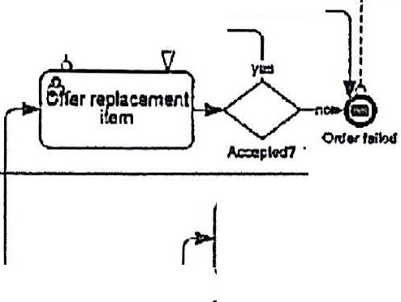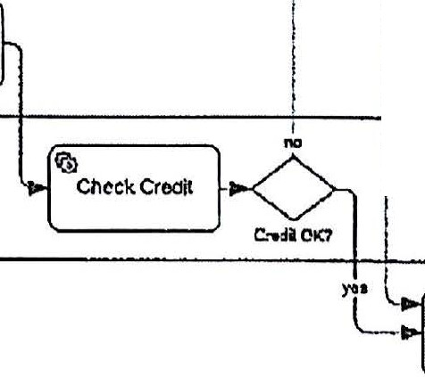

FulrillOnler );,t•



------------------·--------------·-

Figure 3-13. Order process, top-level diagram

But note how much the top-level diagram reveals about this process. We see that the instance represents an order, since it starts upon receipt of the *Order* message. It has *two end states, Order complete* and *Orderfailed .* The source of order failure is either bad credit or out of stock with non-acceptance of the offered replacement. Each end state returns a different *fin al status message* to the Customer. With processes initiated by a request message, it is good practice to return final status *to* the requester from message end events.

1bis is admittedly a simple process, but it is not too different from the top-level diagram 0£ typical real-world end-to-end processes. All the shapes and symbols we used are members of the Level 1 palette. In the next chapter, we'll take a closer look at the complete Level 1 element set.

Chapter 3.BPMN by Example I 31

.

1

*)*

**Scanned by CamScanner**



**CHAPTER 4**

**The Level 1 Palette**

All of the shapes and symbols used in the last chapter are part of the *Level 1 palette,* what BPMN 2.0 calls the *Descriptive P,-ocess Modelin.g Confo,-mance subclass.* If you are willing to ignore event-triggered behavior, you can model almost any process without going beyond the Level 1 palette. With the exception of message flows and Message events, the Level 1 notation is basically carried over from traditional flowcharting.

The following is a complete list of the elements in the Level 1 palette, members of the Descriptive subclass i.IJ. the BPMN 2.0 spec, including some we didn't use in the last chapter:

* Activity: Task (User, Service, None), Subprocess, Call Activity
* Gateway: Exclusive, Parallel
* Start event: None,Message,Timer
* End event None, Message, Terminate
* Sequence flow and Message flow
* Pool and Lane
* Data object, Data store, and Data association
* Documentation
* Artifact: Text ,annotation, Association, and Group

Inthis chapter we'll review each of these elements. If you have done flowcharting before, you may find that BPMN'smeaning is slightly different from what you are used to.

**Activity**

An *activihJ* represents a unit of work performed in the process. Itis always represented by a rounded rectangle. Itis the only BPMN element that has a *performer .* Every activity is either a *task* or a *subprocess.* A *task* is *atomic,* meaning it has no internal subparts descnbed by the process model; the actions and end states of a task are merely suggested by its *name.* A *subprocess* is *compound,* meaning it has subparts defined in the model. 111ose subparts are modeled as a *child-level process,* a.n activity flow from start to one or more explicit end states.

33









Task

A *task* is represented in the diagram by the activity shape, rounded rectangle, wi:h the *task type* indicated by a small icon in the upper lef t comer. A task represents an action, not a

function or state. It should be labcled VERB-NOUN.

Check credit l f



8

Check credit

B[B•K•··-J r:~~"''~~ [ Saipt task J

I ---

ssRule

task

figure 4-1.Top row, lef t to right: User task, Service task, Abstract task. Bottom row,left to

right Send task, Receive task,. Manual task, Script task, Business Rule task



BPMN 2.0 defines eight task types, but the Level 1 palette just jncludes the three most

'

.

commonly used (Figure 4-1, top row). '

* + · A *User task* (left), with the head-and-shoulders icon, means a task performed by a person.
* A *Service task* (center), with the gears icon, means an automated aclivity.Automated means when the sequence flow arrives, the task starts automatically, with zel'o i human intervention. If a person has to just click a button and the rest is automatic,

that is a User task, not a Service task. ·:

* An *Abstract task* (right), with no task type icon, means the task type is undefined.

,,.

*Send and Receive Task*



*Send* and *Receive* tasks are part of the T.evel 2 palette. They are similar to Message events and are discussed in Chapter *7.* The others are outside of the Level 2 palette.



*Manual vs. User Tasl<*



A *M.anual task,* with the hand icon, should only be used in an eXecutable process, that is, an automated workflow. In that context, a Manual task is one performed without any connection to the workflow engine, as contrasted with a *User task,* which is managed by the

engine. *If your proce5S model is not executable, it shoulcl not include Manual tasks.* For non­

executable processes,just use a User task for any human task.

*Script vs. Service Task*

A *Script task,* with the scroll icon, also should only be used in an executable process. In non­ cxccutable processes, a *Service task* signifies any automated process activity, but in an executable process it means the process issues a *service request* to some external system or entity to perform that fWl.ction. The implementation of the service is not defined by BPMN,

but by the internals of the system that perfoi-rns it.

34 I Chapter 4. The Level 1Palette

Scanned by CamScanner

7 ..



A Script task, in contrast, means an automated function *peifonned by the process engine itself.* The implementation is a short program, typically Javascript or Groovy, embedded in the process definition X\i.fL. Because the process engine is usually busy executing the process logic, it does not have time to perform complex tasks, so Script tasks are typically used for simple computations such as data mapping.

lf your process is not executable, it should not include Script tasks. For non-executable processes, just use a Service task (or equivalent Send/Receive pair) for any automated task.

*Business Rule Task*

The *Business Rule task,* with the grid icon, is new in BPMN 2.0. Itsignifies a task that executes a complex decision on a business rule engine. A Business Rule task is effectively a special

type of Service task.

Subprocess

A *subprocess* is a compound activity, meaning an activity with subparts that can be described as a child-level process. A subprocess can be represented in multiple ways in the di<lgram. A *collapsed subprocess* is drawn in the parent-level diagram using a normal-size activity shape with a [+) symbol at the bottom center (Figure 4-2, top); the child-level expansion is drawn in a separate hyperlinked diagram (Figure 4-2, bottom).

Check stock

Fulfill order

-.....--_J

[ Pi "°'"J- 0

Figure 4-2. Hierarchical expansion: Collapsed subprocess inparent level (top) corresponds to child-level expansion (bottom) in separate hyperlinked diagram.



Alternatively, an *expanded subprocess* (Figure 4-3) is drav.'ll as an enlarged *activity* shape in the parent-level .flow that encloses the child-level expansion in the same diagram.

There is no semantic difference between Figure 4-2 and Figure 4-3. They mean exactly the same tling;.)Vhen the sequence flow arrives at the collapsed subprocess in the parent level, the process immediately continues out of the start event at child level. And when it reaches the child-level end event, it resumes on the sequence flow out of the subprocess in the parent level. In fact, in the semantic model, there is no distinction at all;the XML for both is exactly the same. In BPMN 2.0, the only difference is in the graphical model (see Chapter 17).

·Chapter 4. The Level 1Palette I 35

Scanned by CamScanner



Fulfil\ order

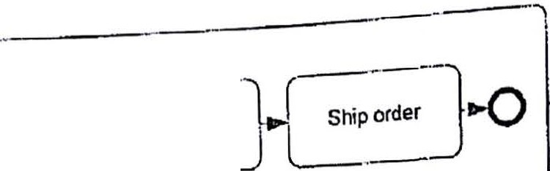

o-81_:"m"k

* ... . arent level encloses the

Figure 4-3. Inline expansion: Expanded subprocess shape m P

cltlld-lcvel process, all on the same diagram.

. . }' expansion is that a sequence

An important BPMN mle to keep in mind when usmg m me fl must

flow cannot cross the subprocess boundary.

. . d outgoing sequence aws

mcommg an . . . th ch

The

'ld-

connect to the subprocess boundary, and there s11ouId be start and end events m e 1

1evel expansion inside the rounded rectangle. F.igure 4-4..is m· correct· Figure 4-3 is correct.



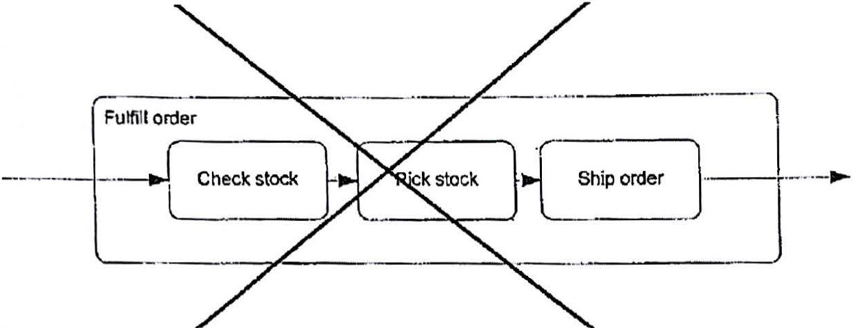

Figure 4-4. A sequence flow cannot cross subprocess boundary.

A subprocess start event must have a None trigger. You may not use a Message start event or Timer start event ina subprocess. TI1at is BPMN rnle, not a style rule. The reason is that the start of the subprocess is not triggered by an event; it is *alwm1s* triggered by the same thing -

arrival of the incoming sequence flow12 .

***Parallel Box and Ad-Hoe Subprocess***

With one exception, a subprocess should always have a single start event. The one exception is when the child level is composed of a set of activities with no sequence flows interconnecting them (Figure 4-5, left). This representation, which has no start or end events,

. .. .is called a *parallel box.* It means that when the subprocess starts, all of its child activities ate

enabled to start in parallel. They can be completed in any order, but all must be complete in order for the subprocess to be complete.

12 *This* is true for a regular subprocess,but an *event subprocess* is an exception handler triggered by an event. Event subprocesscs are not included in the Level 1or Level 2 palettes. 111ey ure discussed inChapter 7.

36 I Chapter 4. The Level 1Palette

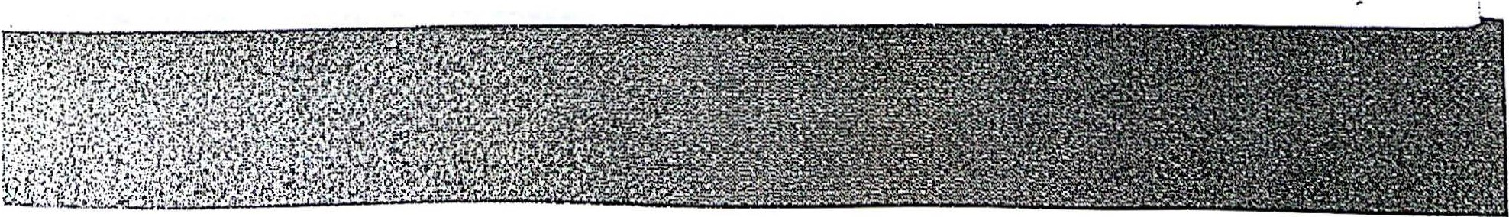

**1'carined by CamScanner**

parat !lox- Sel up b;ink ea:ounl

Set up tomtic I

l'•Yrc cposlt

Ad.ttoc- Set upbank ;iccount

l

Set up credt card Set up aU1omed:

payrol depcsit

jSet up Cl"tdil cud

bankng

Link to other

3CCOun"

i

*("""*

* Set up online

bnl<ing

,.----······-·-

! link lo olhor

;L_accounts _

_j -·-·--·--------=---------



Figure 4-5. Parallel Box (left) and Ad-Hoe Subprocess (right)

A variant of the parallel .box is the *ad-lioc siibprocess,* denoted by a tilde marker at the bottom (Figure 4-5, right). It is essentially the same, except that not all of the child activities must be performed in order to complete the ad-hoe subprocess. It is complete when the performer declares it to be complete.

Both parallel box and ad-hoe subprocess are legacies of BPMN 1.0 and not particularly useful. In BPMN 2.0, ad-hoe subprocess is not included in either the Descriptive (Level 1) or Analytic (Level 2) subclass.

*The Value of Subprocesses*

Subprocesses are a valuable feature of BPMN and one of the least appreciated. Their value has several dimensions:

1. *Visualize end-to-end -pTocess*

BPM as a management discipline emphasizes managing and monitoring the business from the perspective of "end-to-end" processes, meaning customer-facing flows that cut across traditional organizational and system boundaries. To do that you need to understand the end­ to-end process as a *single thing,* not multiple things. Tiw ability to visualize the end-to-end process on a single page greatly aids that understanding, and collapsed subprocesscs enable that. The details of each subprocess are visualized on separate hyperlinked diagrams, but they are all part of a single semantic model. From the end-to-end view you can zoom in to see as much or as little detail as you want, without the need to create and maintain multiple process models.

Visualizing the end-to-end process on a single page assumes the hierarchical style, in which the parent and. child process levels are rendered in separate diagrams. The end-to-end view is just the *top-lroel diagram* in the hierarchy. Itreveals at a glance not only the major steps of the

process but the meaning of the process instance, the process's possible end states, and its

interactions with the customer, service providers, and other internal processes.

Hierarchical rnodeling is not required by the BPMN specification. In fact, for many traditional BPM practitioners, used to working with stickies on the wall to capture process flows from the bottom up, it might be a significant change. But flat models stretching over twenty feet of wall space make it difficult to appreciate the end-to-end process as a single thing. The

Chapter 4.The Level 1Palette I 37

s

*i*

tradi·tional solution to this problem i.s to create separatc h"igh-Jcvel and det.ailed mododlienls,.but

ru.

this requi.res keepm. g those models m.

sync as the proces*s* ch"•1oces·rTic·rarclucal.m e g.m a

BPMN tool does not have thi·s problem, because a sm· gJe semantic model contains both.high- level and detailed graphical views. For this reason, the Method and Style approach rehes on

hierarchical modeling.



1. *Enable t-op-dow11 modeling*

Subprocesses are also valuable to "top-down" process rnodcling. That means starting with lhe top-level diagram, in which collapsed subprocesses represent the major steps of the process, and then adding lhe details of each step in child-level diagrams. A coJ!apsed subprocess with no child-level expansion can serve as a placeholder for un.lmown details while maintaining the integrity of a valid end-to-end model.

1. *ClarifiJ governance boundal"ies*

Subprocesses facilitate distributed process ownership and governance. End-to-end processes frequently cross governance boundaries within the enterprise. Different parts of the process may be controlled by different executives who jealously guard their turf. Problems can arise when the boundaries between process activities are fuzzy.



Subprocesses provide unambiguous demarcation of those governance boundaries. If the top­ level diagram accurately describes the interaction between independently governed subprocesses, then each subprocess can be modcled and maintained independently.

Distributed proc:e governance is aided by a model repository with authorization and versioning features.

1. *Scope event haudling*

1 Event-triggered exceptions are important inreal-world processes, and subprocesses are useful for defining .the boundaries of a single exception handler. An event attached to a subprocess defines an *event handler* that is initiated ilthe event trigger occurs *at any step within the subprocess. H* the same trigger - say an order cancellation message from the customer - is

J handled differently in different parts of the process, each of those parts may be enclosed in a

subprocess with an attached event representing its distinct event handler. We will see examples of this .in Chapter 7.



**Call Activity**

BPMN 2.0 distinguishes a *subprocess,* in BPMN 1.2 called *embedded subprocess,* from a *call activity,* formerly called *reusable subprocess .* This distinction has to do with whether the subprocess detail - the child-level expansion - is defined within the parent-level process or

. independently. If you have some subprocess that is used in more than one process, it is best to define it independently - in its own file - and then *C12ll* it" from each process that uses it, rather than replicate and embed the definition within each calling process.

In the diagram,*call activity* has a thick border, while *subprocess* has a thin bordei:(Figure 4-6).

38 I Chapter 4. The Level 1Palette

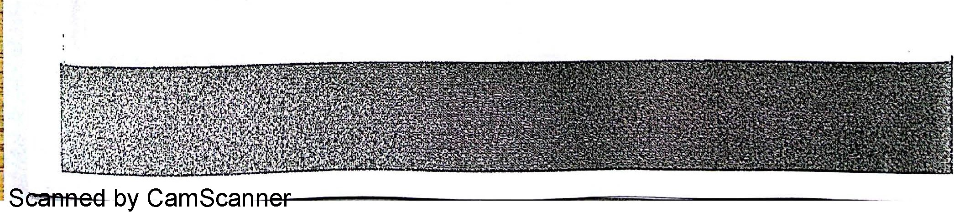



Subprocess



+

Call Activity

r+1

Figure 4-6. Subprocess and Call Activity

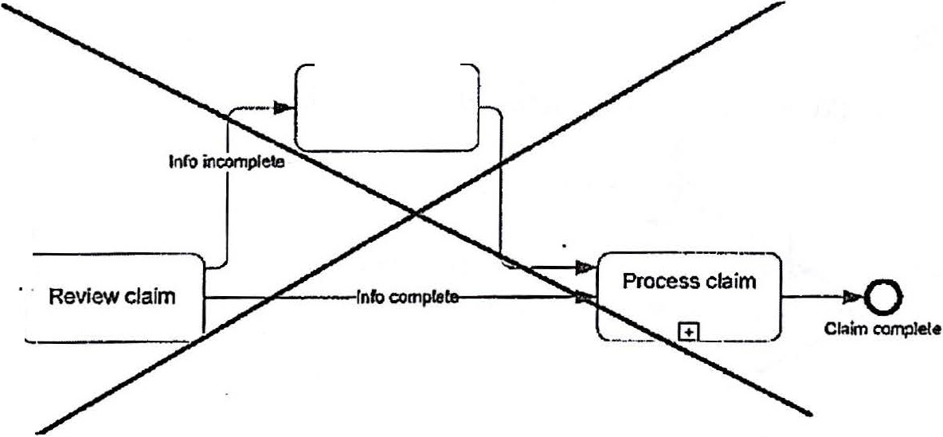

For example, suppose you sell both widgets and widget maintenance. The *Widget Order* process is different fron'l. the *Maintenance Order* process, but they share a common *Billing* subprocess. If you use a regular subprocess, you would need to replicate the *Billing* definition inside both *Widget Order* and *M aintenance Order,* and maintain that synchronization whenever *Billing* changed. A better way is to make *Billing* an *independent top-level process* defined in a separate file, and invoke it from *call activities* in *Widget Order* and *M aintenance Order.* The call activity points to a *process* element in the called model, in this case *Billing.* With subprocess, the calling and caUed processes are defined in the same model; with call activity they arc independent.

You can similarly use call activity to call a reusable *task,* in BPMN 2.0 called a *global task.* TIU.s call activity looks like a regular task, except for the thick borde:r. For Level 1and Level 2 (i.e., non-executable) modeling, global tasks add little value, since the only "detail" included in the task definition is its task type and name. But in executable BPMN a User task definition, for example, would include task data, its user interface, and similar details. To reuse that task definition in multiple places (in. the same process or across processes), you would define it as a global User task, with multiple call activities pointing to it.

Gateway

A *gateway,* the diamond shape, "controls" process flow, splitting it into alternative paths. Without a gateway, when a BPMN activity has more than one outgoing sequence flow, the process splits into multiple *parallel* paths. Giving them alternative labels may have worked in flowcharting, but it doesn't work in BPMN (Figure 4-7). If you mean the process should take one path or the other, you need a gateway (Figu:re 4-8).

Obtain missing

info

....

e._..--1

Receive claim

Figure 47. Incorrect: Alternative paths require a gateway in BPMN

Chapter 4. The Level 1Palette I 39



Scanned

by CamScanner



. ,

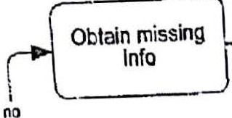

Process claim

---0.

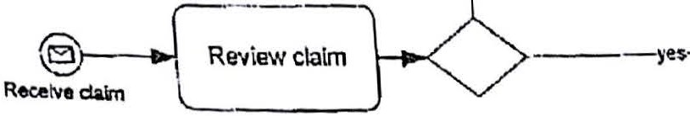

lnfocomi>lele?

Cl3\m comple

figure 4-8. Correct: Alternative paths requite a gateway in BPMN

*Exclusive Gateway*

"BPMN defines several types of gateways, distinguished by the symbol inside the iliaroond, but the one shmm here, with no symbol inside, is the most common. Officially named the exclusive *data-based gateway,* it .is more commonly known as the XOR *gate"'..vay.* "Exclusive" means only one of its outgoing sequence flows, or *gates,* is enabled in any instance. "Data­ based" means the enabled gate is determined by evaluating an expression of process data. Level 1or Level 2 BPMN does not include formal data expressions, so the gateway conditions are expressed inthe cliagrarn by the *labels* of the gateway and gates.



Vvhen a gateway has two gates, I like to label the gateway as a *question* and label the gates *ye.s* and no. As we saw in Chapter 3, matching such a gateway label to an end stale of the preceding activity helps you trace the logic from parent to child process levels in a hierarchical model.

"j There axe two alternative ways to draw the XOR gateway. One has no symbol inside the diamond; the other has an X inside (figure 4-9). There is no difference in meaning between the two, but the spec asks that you pick one way and use it consistently. I favor the one with no symbol inside.

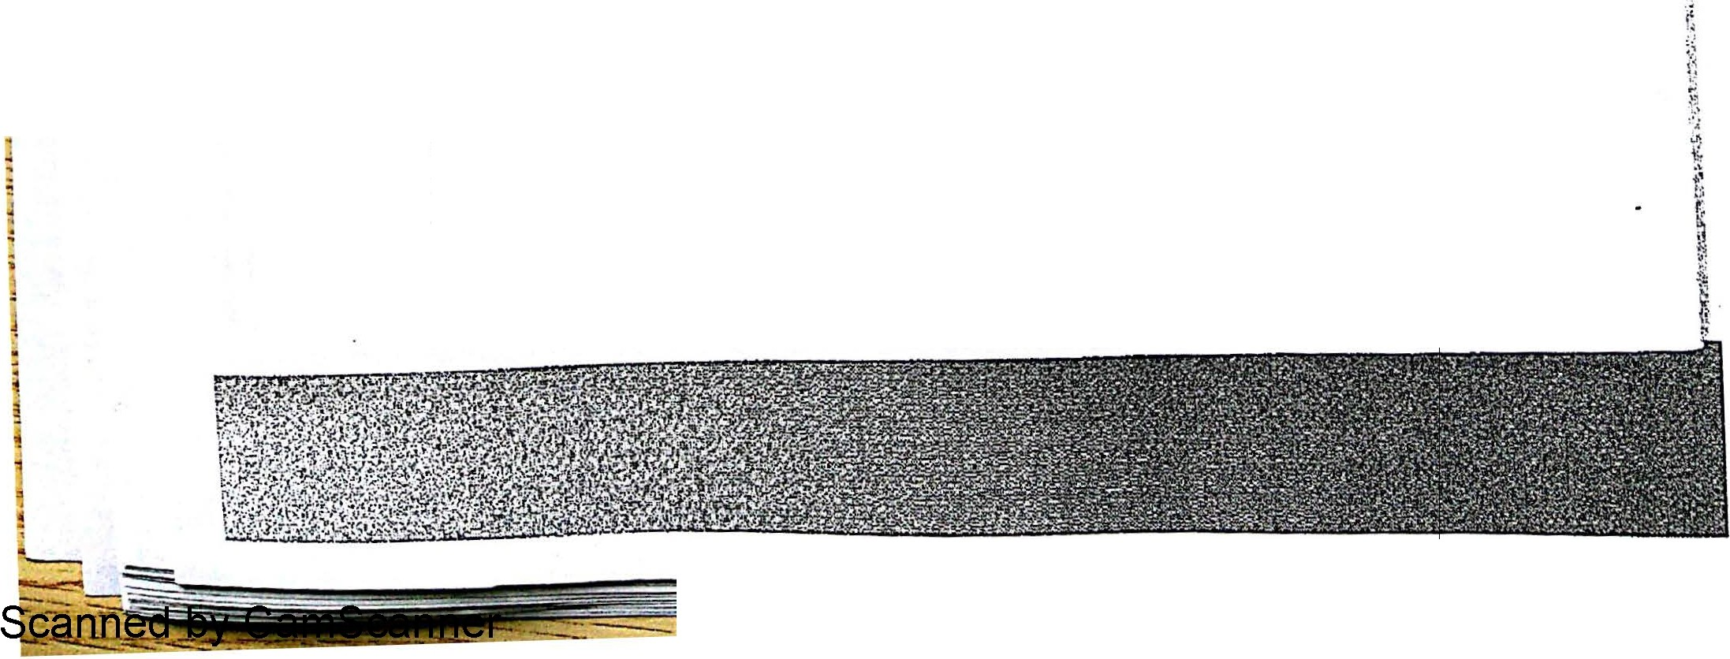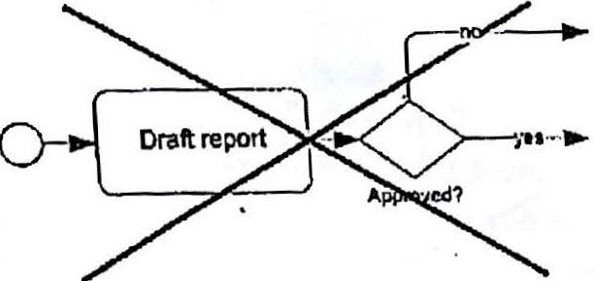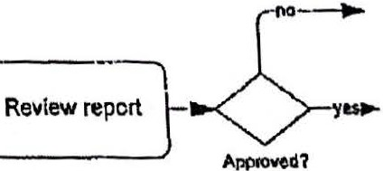



Figure 4-9. Exclusive (XOR) gateway, shown in alternative representatins

"

Draft report 1-

·"'

.;

'j

Figure 4-10. A gateway cannot *make* a decision; it only *tests* a data condition.

An important difference between a BPMN gateway and the s\milax-shaped " ecision box" in flowcharting is that *a gateway* does *ri.ot "make" n decision;* it *just* te.sts *a data concW on.* A gateway

40 I Chapter 4. The Level 1Palette

cannot approve or reject for e y

1

the task can test the deci, . xmp e. ou need a task to do that. Then a gateway following

111e left dt'"'oram m· r.· sion tas < end state and route the subsequent flow based on the result. "o .1.•1gure 4 10 · ·

- Is incorrect in BP1v1N;the one on the right is correct.

***Parallel Gateway***

A *parallel gateway* (Figu ll)

4 1

lf 1 re - , a so called an *AN D-gateway,* with one sequence flow in and

1

mu e sequence flows out, signifies a *parallel split* or *AN D-split.* It means that *all* of the

outgom sequence £1 . b .

* 0 ows are to e followed m parallel, unconditionally. It is distinguished

from the exclusive gateway by the + symbol inside the diamond.

Figure 4-ll. Parallel gateway

Each outgoing path thus represents a concurrent thread of process activity, meaning they overlap in time. Parallel paths may either be joined downstream or they may lead to separate end events. In the latter case, each parallel palh must reach an end event in order for the process level to be complete. _Following an activity or start event, multiple outgoing sequence flows means parallel split, so an AND-gateway is unnecessary inthat case. The two diagrams in Figure 4-12 have identical semantics.

*(* Provide proof of

Enter vehicle data

L

>---1 Insurance ;

Pay renewal fee **r>{)**

-----"4J Pass smog check -----..

0- Enter vehicle data t------ >i Provide proof of 1r--p-.;.

Insurance

*r--....,* Pay renewal fee

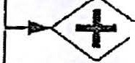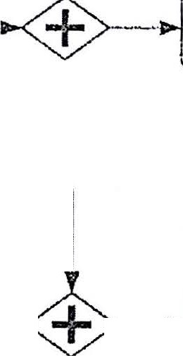

Figure 4-12. Parallel split gateway is technically redundant; both diagrams mean tbe same

thing

In Figure 4-12, the parallel gateway drawn with multiple sequence flows in and one out is called a *parallel join* or *AND-join.* It is a type f *synchronizing j oin* because it requires *all* of its incorrring flows to arrive before enabling the outgoing flow. An AND-gateway may ONLY be used to join paths that are unconditionally parallel. Typically this occurs only when the paths

Chapter 4.The Level 1Palette I 41

**Scanned by CamScanner**

were originally the result of a parallel split, either using the parallel split gateway or multiple sequence flows out of an activity.



Unlike the AND-gateway split, the AND-join may *not* be omitted. Dfrectly merging parallel sequence flows into an activity, without joining them first, triggers the activity (and everything dmvnstream from it) multiple times. That is usually not what you mean. Since a sequence flow label sign\fies a condition cmd AND-gateways are unconditional, you should not label an AND-gateway or its gates.

Start Event

A *start event* is always represented as a circle with a single thin border. Its purpose is to indica te where and how a process or subprocess starts. Normally a process or subprocess has only one start event. We saw hmv a parallel box or ad-hoe subprocess may have no start events, and we will sec in this section how a top-level process (not a subprocess) may have more than one.

In a top-Level process, the icon inside the circle, called the *trigger,* identifies the type of signal that instantiates the process. Just .as important, the trigger identifies the *meaning* of the process instance as the handling of that single triggering event. A subprocess MUST have a *None* trigger, no icon inside, because a subprocess is not initiated by an event but by an incoming sequence flow.

BPMN 2.0 defines seven start event triggers,,but the Level 1palette indudes only fol:lr of them (Figure 4-13).

0 @) @ @

Nona limer Multiple

Figure 4-13. Level 1Start events

*None Start Event*

A *None start event* has no trigger. In a top-level process, it either means the process trigger is unspecified or signifies manual start by a task performer, as discussed in the previous. chapter. Usually None start events are unlabeled.

A subprocess MUST have a None start event; it is a specviolation to have a triggered start in a subprocess.

*Message Start Event*

A *Message start event,* discussed in the previous chapter, means that the process is triggered

µpan receipt of a message, a signal from outside the process. It signifies a process that starts upon external request, and the process instance represents the handling of that single request.

In order to. maximize diagram clarity, a Message start event should be labcled *Receive* X, where *X* is the name of the message. Also, wheri using Message events you should get in the

42 I Chapter 4.The Level 1Palette



Scanned by CamScanner



habit of drawing the messag fl d . .

n • e ow an labehng it ·with the name of the messao-e. These are

style rule::;, not rules ot the BPMN specification. o

***Timer Start Event***

The *Timer start event1* with a clock 1·con, s1·gm'f1'es a scheduled process, usual1y a recurn·ng schedule. The start event should be labeled to indicate the schedule such ns *Monthly* or

*Fridays 4pm.* ' ·

Like a Message start event, a Timer start event also reveals the aleaning of the process instance. Each instance represents exactly one of those scheduled starts. For example, Figure 4-14 shows a monthly sales reporting process. If some activity, say *Review loss reports,* cannot be completed by the n1onthly sales report deadline, you cannot simply loop back in this diagram to mean include in next month's report. Next month'sreport is a separate instonce of this process. Every activity in the process pertains only to this month's report.



01

c

t

8.

8Review loss

reports

enerate sales report

aC:U:

*Ill*

*Q)*

i*e*i*n*i

Figure 4-14. Scheduled process

***Multiple and Multiple-Parallel Start Event***

The *M ultiple start event* (Figure 4-15, left) has a distinct shape - a pentagon - but does not represent a distinct BPMN element inthe semantic model. It mearn; that the process could be initiated by *any one of multiple triggers,* say either Message A or Message B, or possibly either by regular schedule (Timer) or on special request (Message). The start event label should indicate all of the possible trigger conditions.

c:

*Q)*

I "-----

I

....

Q)

"O

'>

0

et

*y*

I

....

Q)

E

.s

*rn*

:J



*r*

0

*Y*

I I

Partient -::- -.=: :-j·

I

cbim PrOllid&t *:*

o

I I

Aj:pflCl!loa :

**form 1**

Process

; Fee p•ymenl

@--

.;:.- --!

appl cation -""'°

Receive darn • *_J*

Figure 4-15.Multiple and Multiple-l'arallel start events

Rccelw "fpr.catioll

Ind fM

The *M ultiple-Parallel start event* (Figure 4-15, right) was added in the Finalization phase of BPMN 2.0. It is very rarely used, and it is not part of either the Level 1or Level 2 palette.

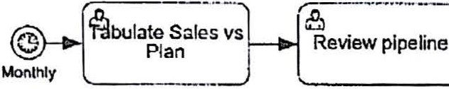

Chapter 4.The Level 1Palette I 43

----



t distinct semantic element. Where

Likl! the Multiple start event, it is a dislinct shape but no a 55 Multiple-Parallel

the Multiple event means *arty* of . . . . ·11 start the proce ' *i*

its multiple triggers wi . . They

e

can occur in

means the process

any order.

.

requires

*all* of the

.

triggers

to occur b fore instantiation. c

*Alternative Start Events*

·rhe path out of a Multiple start event i·s the same regardless of wh. i·r.h trig0cr. sign.al is received. But what about the case where the initial process activity depends on whi trigger occurs? For that you don't use a Multiple start event; you just use *more them one simple start event,* typically Mes.sag.

o

You can only do this in a top-level diagram. Each start event represents an *alternativ e* trigger for the process. Once triggered, the process or subprocess instance will *ignore a signal subsequently received by any other start event.* Such a signal would initiate a *new* process instance. '

A common use case £o1·this is *channel-dependent start.* For example, a process triggered by customer request may require different .initial step if the request arrives via the call center versus web or fax, but has the same backend processing regardless of the contact channel. The best way to model this is with multiple Message start events, each representing an alten ative start point for the, process (Figure 4-16). Remember that this is *not* the same as a Multiple start event. You would use Multiple start if any of the triggers initiates the *same* path.You would use more than one start event if each trigger initiates a. *different* path.

@--

Enter phone ord .

Reoeive phone

order

--EL.

._J

l FulliU

-

order- -.()

Re""web order

®--

,-- Fl Ofder corr.pletc

Val1date web I

order *_)*

+

Figme 416. Channel-dependent start

**End Event**

* - ·An *end event* is always represented as a circle with a single thick border. It indicates the end of a path in a process or subprocess. An end event in either a process or subprocess may be drawn with a black or "filled" icon inside, indicating the *result* signal thrown when the event is reached. p-nlike start events,it is commonplace to see more than one end event in a process or subprocess.In fact, the Method and Style approach requires a separate end event for each distinct end state in a process level.

BPMN 2.0 defines nine end event types, distinguished by theiT result, but the Level 1palette includes only three of them, plus Multiple.

44 I Chapter 4.The Level 1Palette

Scanned by CamScanner



-

- '

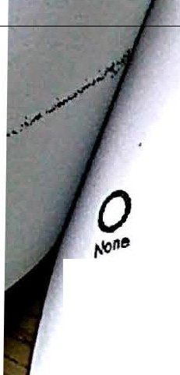

®



® ®

Message Termiruite Muli;ir

figure 4-17.Level 1end events

*None End Event*

A *None* end event (no icon inside) . .

is reached. In a process le\!•el .

s1gmhes that no resuIt · al .

thrown when the end \'en

th

* parallel £1 · ·

b t

sign is

paths in separate end .events

w1 H d ow, it 15 technically allowed to end the par<1llel

they are all None end ·event; 'tu' 1esy 0 not represent distinct end states. For th::it reson. it

be

1

*1* IS t to merge the th · · 1 •

don't need a gateway to · . · pa s into a smg e None end event. 1ou

one. Since the process

)Om paralleJ paU1s *t* a *N* one

d event; .

fact, you s

. not use

1 1. ' a J · en m

hou1d

a1'oin is always im 1· .deve l not complete util all parallel pths have reached an end event,

* P le. at a None end event.

*Message End Event*

A *M essage* end event (black enve1ape i.con) s1. gru.f1.es that a me.. aoe is sent upon nadw.



l U1e

0

end event. Best pracf1ce · t d · "'

IS o raw· a message flow from the event to the external pool. A

commo use c.ase is return of a final status response to the Customer. *If* you merge parallel paths dirctly mto a Message end event, the message *is* triggered multiple times, so use a join gateway if you mean to send the message once.

*Terminate End Event .*

A *Terminate* end event (bulls-eye icon) is a special case. Reaching Terminate in a process or subprocess immediately ends that process or subprocess, even if other parallel paths are still running. Reaching Terminate in a subprocess only ends that subprocess, not the parent-level process. Some modelers use Terminate simply to indicate an exception end state. However, I recommend reserving Temiinate for the case where its specific semantics are required,. an exception inone parallel path of a process level.

*Multiple End Event*

A *Multiple* end event (pentagon icon) is similar to the Multiple start event, in that it has a distinct shape but does not represent a distinct semantic element. It just implies more than one ordinary result is thrown, for example two different messages.

Sequence Flow

*Sequence flow,* drawn in the diagram as a solid line connector, represents the sequential execution of process steps: 'When the node at the tail of a sequence flow completes, the node at the arrowhead is enabled to start. In an executable process,it represents an actual flm·\.'of control: When the tail node completes, the arrowhead node is autoatically started by the process engine. The only elements that can connect to the tail or head of a sequence flow are

Chapter 4. The Level 1Palette I 45

Scanned by CamScanner

* + ·. · th BPMN 2.0 metamodel. In other



actnrities, gateways, and events, called *flow nodes* m e

wordL :.tence flow represents *orc11estratiorr.*

I

\

Figure 4-18. Sequence flow

. ·· d · I 1 st l1'e on a continuous chain of



All

activ1ties, gateways, an evenl-s m a process eve mu

sequence flows from start event to end event. (The spec does not absolutely require this, but Method and Style, with a few exceptions like the parallel box, does require it.) The chain of sequence flows is confined within a process level, so *a 8equence flow may not cross a. subprocess*

*or pool boundary.* This is a fundamental rule of BPMi\J. Also, both ends of a sequence flow m.ust be connected to a flow node. If one end is lef t unconnected, the model will not be valid.

Message **Flow**

*Message flow,* drawn in the diagram as a dashed line com\ector, represents cornmwtlcation bctv,reen the process and an external entity. A message flow can connect to any type of activity, a Message (or Multiple) event, or black-box pool. Note: You may not connect a message flow to the boundary of a process *pool;* you must directly connect to an activity or event inside the pool. Elements connected to the head and tail ends of a messc:ige flow may not be part of the same process (including its child levels).

0------- !

1

Figure 4-19. Message flow

In some cases, a message flow indicates the *possibility* of message communications, not the certainty of it. For example, a User task with an outgoing message flow means the task *mny* send the message,not *must* send the message. Ifyou.want to indicate the certainty of sending or receiving of a message,you should use a Message event or a Level 2 *Send* or *eceive task.*

**Pool**

The *pool* shape is a rectangular box (Fjgure 4-20). It can be either horizontal, with the label boxed off on the left, or vertical, with the label boxed off on the top. (Boxing off the label distinguishes a pool from a lane,which does not have its label boxed off.) A pool containing

. . •flow elements, called a *process pool* or *white-box pool,* should be labeled with the name of the

*process.* An empty pool, called a *black-box pool,* should be labeled with the name of a *business*

*entity or role* such as Customer or Seller.

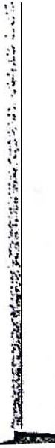

46 I Chapter 4. The Level 1Palette

Scanned by CamScanner

*rJ)*

'

I I

'I

I

I

Order

*{J*

I I

I

I

lnvOice

*rJ)*

<!> I

u I

0.....

0......

Q)

"O

0

Rae.Iva order

Process crder

--

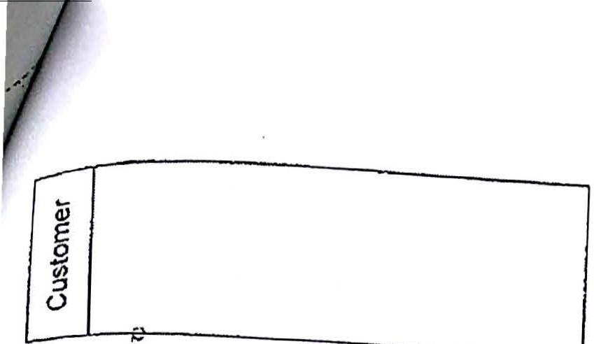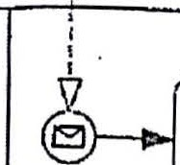

Figure 4-20. Blackbox pool (top) and process pool (bottom)

In BPMN 1.2, a *pool* represented a container for a *process.* BPMN 2.0 changed the definition in a way that muddies the waters but does not fundamentaUy affect how pools are used in practi - Effctively, a pool is still a container for a single process, but technically it represents a *participant* m a *collaborntion .* That migh t suggest you cannot use a pool in a diagram unless you have two or more of them exchanging message flows, and until the end of tbe BPMN 2.0 drafting period, that was indeed the case! But common sense prevailed at the end. A diagram may show only a single process, enclosed in a pool. In the semantic mode], it is a defined as a collaboration with a single participant ... the BPMN equivalent, *l* guess, of the sound of one hand clapping.

In the XIVlL there is no *pool* semantic element; there is only *participant .* Pool just means a shape in the graphical model that points to a *participant* in the semantic model. But since a participant can reference just one BPMN *process,* not more than one, it is effectively equivalent to a process. A black-box pool is a pa rticipant that has no process reference.

Although advocate labeling a process pool with the name of the process, it is not uncommon to see BPMN diagrams in which process pools are labeled with the name of an organization, such as a company or department. I disagree with this practice for several reasons:

1. There is no other BPMN element in the diagram where the process name appears.
2. A collaboration diagram could contain two internal processes, interacting via message flows. Such a collaboration requires two *participants,* each referencing a different process, although the members of both participants may be exactly the same people. We'U see an explicit example of this in Chapter 8.
3. Labeling a process pool with the name of an organization, such *as* a department, encotuages splitting a single process into multiple independent processes. There are occasions where modeling an end-to-end business process *as* multiple BPMN processes is appropriate, but most of the time it is best to model departments or other organizational units as *lanes* within a single process, not separate pools.

Chapter 4. The Level 1Palette I 47

**Scanned by CamScanner**



. flows it is not required to draw a



H a diagram depicts only a single process with no message . 'between multiple processes,

pool at all. However, .

any d' tl at shows a collaboration

that pool was considered

m iagram \ MN

at most *one* of them may omit the pool shape. In BP 1

"invisible"; in BPMN 2.0 the pool does not exist in the model.

1•2'

In hiernrchical modeling, where a child-level expansi.on i.s dra*vm* on a separate hv"perlinke*l*d

dingram, it is best t"O omit a pool shape endosm. g the ch1'ld process•

lev.el. (So•me *too* s

automati.cally draw a pool in the chi.ld level 1.£ you want to show 1anes,but this a tool issue not

a BPMN requirement.) It·you enclose the clu·ld-level expans1·0n m·

a pool, its label should

match that of the *top-level process;* it should *not* be labeled with the name of the subprocess'. In lhe tool I use for my BPMN training, even if you give the same names to the parent and cll.ild­ level pools, two separate participants will be created in the XML unless yo teJI the t I they represent the same entity. It's easy to do, and it makes the XML come out nght...but tt s alo easy to forget. We'll come back to this in the BPMN Implementer's Guide section of this

book.

Lane

In BPMN 2.0, a *lane* (figure 4-21) is an optional subdivision of a process level. Like pool, a lane is drawn as a rectangular box, but its label - at the left for a horizontal lane or at the top for a vertical lane -is not boxed off. BPMN aJlows you to draw lanes without enclosing them

im;ide a pool (although some tols do not).

Lanes are a holdover from traditional swirnlane flowcharts, where they were used to associate process activities with particular actors - departments or roles. They are still typically used for that purpose, but BPMN 2.0 actually allows them to be used for *any* type of categorization, for example value-adding vs. non-value-adding activities. You can even have multiple sets of categorizations, called *lanesets,* in the semantic model, all associated with the same process level. One laneset might indicate the performer *role,* for example, and an altemative one might indicate the responsible *department.* A particular diagram in the graphical model may

reference just one of the lanesets.



Figure 4-21.Lanes

BPMN 1.2 was vague about how lanes in a chi.Id-level diagram relate to lanes in the parent level,. but it *is* clearer in BPMN 2.0. Each Jane.c;et definition applies to a specific process level. If you want to reference the same lanes in parent and child-level diagrams, you need to replicate the laneset at both levels of the model.

4s I Chapter 4. The Level 1Palette

Scanned by CamScanner

•,.'.

r

*J..•'*



A Jane in a process level mny contain a *h1·id z*

\Tl1 nested inside its pa t 1 *c*

*aneset.* The *child* lanes, also called *sublanes,* are

drav ren ane For example 1 ·

sublanes roles with· th .d · ' a parent ane might represent a department, m at epartment.

antl

Jf you use lanes in a process leveI' au i·ts fl ·

ow nodes

must be associated with one lane or

another. You may not depict some in a lane and others not in a lane. *BPMN* has no rules



about sequence flows crossing lane boundaries.

**Data Object and Data Store**

One of the biggest .changes from BPMN 1.2 to BPMN 2.0 concerns the rnodeling of data and data flw. In BPMN 1.2, data objects were considered *a1'tifacts,* diagram annotations with no semantics or rules. In BPMN 2.0, *dnta object* was upgraded to a first-class semantic element, along wifu a new element, *datn store.* Even though both data object and data store are part of the Level 1palette, the new defiitions treat data from the perspective of a developer doing executable process design.

The *data object* shape looks like a dog-eared page (figure 4-22, left). Besides the *name* of the data object, the label may indicate *its state* by enclosing it in square bracke. The *data store* shape (Figure 4-22,right) is a cylinder, similar to the symbol for a database or storage device.

D

Data object

Figure 4-22. Data object and data store

A *data object* is really a programming construct. It represents a *local variable* in a process level, a piece of temporary data stored inside the process instance while it is running. Its value is visible to other elements in the same process level or one of its children - for example, it can be passed to the input of a process activity or be tested by a gateway condition - but is invisible to a sibling or parent-level element. And when the process level (top-level process or subprocess)·ends, the data object goes away. In other words, it works like a variable in a computer program, not what a modeler normally means by "data".

A *(/ata stare* represents *persistent datn,* such as information stored in a database or business system. It can be queried or updated both by the process and by entities outside the process. It docs not disappear when a process level, or the process as a whole, ends. It is more often what a processmodeler means by "data".

Data object and data store connect to other model elements through *data associations,* dotted line connectors that look a bit like message flows except the lines are dots not dashes and fue arrowhead is a V, not a triangle. With data objects, one end of the data association is connected to an activity or event, and the other to the data object. In that case, the data association represents a *mapping* between that variable and a data input or output of the activity or event. The mapping may b.e a simple copy or a transformati.on, but only the data association connector and label are visible in the diagram.

Chapter 4. The Level 1Palette I 49

**Scanneu by cmI iCdi ii** j@ j **LLtE!**



1



. . h

* + ted by a *data o•.itp•*•*it association* from an activity or

Data flow withm a process is t us reprsen . . from the *data object* to another acti'Vity event to a *data object,* followed by a *data input association* d' t'onal data association (drawn

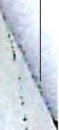

. ll d t se a non· irec l

0

or event (flgure 4-23, nght). You are a owe u flo"' connecting the source

without the arrowhead) between the data 0b' C:t: nd a sequence ..

)€ a c. h ords

the semantics are

*II* (F'

and target objects as a "visual shortcut

re 4 *r* , left)· In ot er w •/

tools will do this

i - ;; · ·

T ll BPMN

those of the right diagram, even if you draw it as on the left. (Not a

for you; best to model it as jn the right-hand diagram.) ' ;

or.i.r

D

,.............. *i*

o.:ar ;

i"'o""to . ' Pro"''o'.:}o

Figure 4-23. The lef t diagTam is considered a "visual shortcut" for the data flow in Ute right

one.

A data store represents a single unit of information stored in a system, such as a database record, not the system or database as a whole. Data association directed into the data store represents an *upclate* operation, while data association directed out 0£ the data store represents a *query.* In Figur-; 4-24, the task *Proc.ess Order* updates the account balance in the data store

*Customer Accoun*..*t*..*.*...........u...



...

...

Order ;

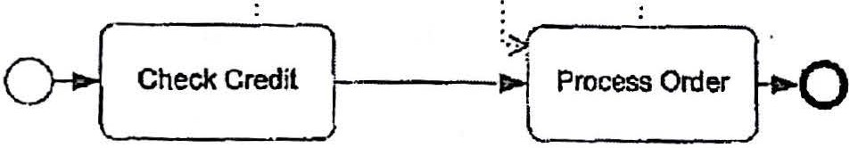

Figure 4-24. Data store represents persistent dat.a accessible to the process.

The DPMN metamodel imposes one more bit of complexity here. 111e data store itself is a root element in the semantic model;it is defined outside of any particular process. 'TI1e element drawn in the cliagram is actually a *data store reierence,* which is contained within a process level (otherwise you could not connect a data association to it). If you interact with the same data store from two different parts of your model you may need to draw separate data store references. But the BPMN tool should hide this complexity from the modeler.

**Documentation,Text Annotation,and Group**

The BPM.1"1model as a whole and most of its individual elements each contain a *documentation* '.! element in the XML, into which you can stuff as much information as you please, either 1 directly or via links to external documents. These documentation elements are part of the ;i Descriptive subclass (i.e., Level 1}, meaning any tool that claims conformance is expected to be ; able to import and display them. However, *documentation* has no associated graphical

element. Jn other words,it doesn't show up in the diagram. 'l

I

j

50 I Chapter 4.The LevellPalette



·"

If you want to put an annotation in th d. .



diagram by a square bracket sl f e .iagram itself, use *text annotation,* indicated in the

b £ 1 0

annotations are not supposed t

iape rammg a b't f user-entered text (Figure 4-25). Text

. o e ree-floating but ttach d . .

*associatio* v1a

on-direclional A . . a e to some graplucal element a

11 11• ssocration looks th . . . ·

arrowhead. Text annotation and . . e sa.me as a data assocrahon without the hat does not affe t association are *artifacts,* meaning supporting information

t c process flow.

-- rLr.::::::_:1J-er--

Figure 4-25. Text annotation and association

Finally, there is.*Group,* dravvn as a rounded rectangle with a dot-dash border (Figure 4-26). Group is also an artifact. Essentially it is just a box drav.m around a set of elements in the diagram to indicate some relationship between them. Officially, the spec says this: "The grouping is tied to the CategoryValue supporting element. That is, a Group is a visual depiction of a single CategoryValue. The graphical elements within the Group will be assigned the CategoryValue of the Group." However, I have *never* seen this CategoryVa!ue mechanism used in practice. I£ you are inclined to use it at all, you should consider Group



just a visual highlighter in the diagram.

,·-·-·-·-·-·-·-:-·-·-·-·-·-·-·-·-·-·-·-·-·-·-·-·

i GroUplabel 

I·-·-·-·-·-·-·-·-·-·-·-·-·-·-·-·-·-·-·-··-·-·-·-·

Figure 4-26. Group



\

I\

\

r'

:\

i \

ii

ii Chapter 4. The Level 1Palette I 51

i

'

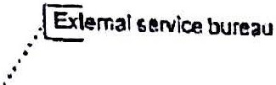

"----' :c m ::::

*Zz* :z.· a



We've now covered the full Leve'l l workm'



' ..._ \..

**CHAPTER 5**



**The Method**

g set. 111erc t.s a lot more left to discover at Level 2,

'- . .. *-.:.*

bttt we know enough alreadY *t*o handle the rna1·on·ty of process modelm· g requI·Tements. So we are now ready to discuss the Method.

The Method is not part of the BPMN specification. OMG proudly declares that BPMN has no official methodology, since it is intended for a *wide* variety of uses by people with divergent interests and skills. But in my experience, most people using BPMN are trying to do the same thing - *create a non-executable process diagram tlzat convetjS the process logic* in *a meaningful way.* Whether they are simply trying to document an as-is process or create business requirements for an automated to-be solution, the attributes of a "good BPMN" model are pretty much the same. The Method is an attempt to standnrdize the sl:ructure of such a model in order to maximize shared understanding of the diagram. If everyone in the organization structures their process models .according to the same principles, they are more likely to understand models created by others.

**Goals of the ·Method**

1he Method is a recipe for going from a blank page to a complete BPMN model in. a consistent, well-structured way. It js based on a *hierarchical modeling style* that reveals important basic facts about the process as a whole from the top-level diagram, and lets you add as much detail as you want in child-level diagrams. It leverages *label-matching* as an aid to tracing the process logic from the top level diagram down to the lowest level of detail, even if the hypei:lfriKing of the "live" model in a tool is not available. The Method is prescriptive, and it will help get you started on the right foot. However, following my Method to the letter is less important than establishing a prescriptive methodology of your own and deploying it consistently across your organization.

Let's review once more the overarching principles of "good BPMN". They include:

* Completeness. The essential elements of the end-to·end process logic should be captured in the diagram, including how the process starts, its distinct end states,

53

**Scanned by CamScanner** -



. . . tion with external entities such as the what the -instance represents, and 1ts mterac



requester, service

. , and ther internal processes.

. . .

providers o ·

. . h ·tivities are conditionaJ, which are

* + Clarity. Details of the process flow - whtc ac . e handled - should be

performed .

parall l .th thers, how various exceptions ar cr'ith your process or

m e w1 o

f .1.

unambiguous from the diagram aIone, even to those un arm iar ¥\

. k

even your termm· ology. That· means usi·ng label-matching to ma e

the logic traceable

. £

from the top level down in a

. al rood I e when workmg rorn paper

copies.

hierarchic

e , ev n

* + - Shareability between business and IT. BFMN as a *language* ca.n be .shared by

business users, business analysts, and developers. But we're aiming higher. We

want to create individual BPMN *models* that can be shared between business and IT. That's not easy. It demands that business users and business analysts apply more rigor and attention to dl!tail than they may be used to, and it demands that developers describe process activities in terms of the business functions they perform rather than their specific implementation.

* + - * Structural consistency . Given the same set of facts about how the process works, all modelers ideally should create more or less the same process model, at least the same overall strucrure. lf you can achieve that kind of consistency across your organization, it greatly enhances the abiUty to understand models created by others.

These principles of "good BPMN" are the goals of the Method.

**Hierarchical Top-Down Modeling**

The Method describes a hierarchical top-down model.ing style. Dut what does that mean, and why do I recommend it?

*Hierarchical* means graphically representing the end-to-end model as a set of linked process diagrams representing distinct *process levels.* That is, a collapsed subprocess in the parent­ level diagram is expanded in a separate child-level diagram. Collapsed subprocesses in that child level may be further expanded in yet another diagram with a "grandchild'' relationship to the first. A sing1e top-level diagram stands atop the hierarchy, and the number of levels nested below it is unlimited.

In contrast, a *flat* process model places all steps of the process, even the finest details, in a single diagram. If subprocesses are used at all -and sometimes they are not -they are shown expanded "inline," as described in Chapter 3. ·A flat end-to-end process model i·arely fits on.a single printed page, unless output by a large format plotter., Depending on the tool, it may be possible to print it inseveral Letter/At1-size pieces and tape up the mosaic on a wall. There is also a BPMN element, caJ}ed a *Link event pair,* that can be used to split a single process level in the semantic model across multiple diagrams. These diagrams are siblings;they do not have

a parent-child relationship.

54 I Chapter 5. The Method

I...

**Scanned by CamScanner**

f.{ierarchical modeling nl.eans th .

. e semantic model ·

A BPMN · . 15

diagrams. *diagram* in represented visually by multiple

paper •

requird to print it)

IS eqmvalent lo a *I* · *z page* (even if more than one page of

is

single semantic model.

Th d'

* e iao0-rams

are

*ogica*

not separate models, just separa te *views* of *a*



A *single semantic model* means .

end In fact the se t' a smgle process definition describes the entire process end-to-

. ' man ic model by itself doe *t dis* · · . . .

5

representations· tl Xi\.1 . . . no tmgwsh behveen h1crarch1cal ana flat

the diagram la ; u einforL 15.Identica;. The difference between them is in the *graphical model,*

) 0 mation. We 11 talk more about the graphical model inChapter I 7.

*Top-down* means beginnin b d . .

. . · g Y un erstanding the end-to-end process as a whole, enumerating

Its m_JOf step in a *high-level map,* and then arranging those steps in a *top-level process diagram* that Ll on a smgle page. From there you proceed to drill dovm to define the internal logic of each high-level map activity in a *child-level diagram,* revealing only as much detail as required for your purpose. Top-down forces the modeler to start with the big *pictuie,* adding *only* the details needed for the immediate purpose. Thi;.stands in contrast *to* the traditional approach in which the process definition is gradually built up from the bottom based on SME interviews: *First we do this, and then they do tluit, and then....* That approach can get bogged down inunnecessary detail, and may even lead to wasted effort modeling detaHs that are not even part of the process.

Top-dov.'ll usually implies a hierarchical modeling style, whereas bottom-up often leads to flat models. I favor BP.MN tools,like Process ModeJer for Visio or native Visio Premium 2010, that nahrrally support the hierarchical top-down approach by automatically creating a linked child-level diagram from a collapsed subprocess.

**End State**

A key concept in the Method is the notion of *end state.* You can search the BPMN 20 specification from cover to cover and never see that phrase once. Actually it's net a BPMN term, but a common sense business term. Recall that an activity in BPMN is an action performed repeatedly in the conduct of business. Each instance of the ctivity has a well­ defined start and end. When each instance of the activity is complete, you could ask the question, *haw* did it end? Did it complete *successfully* or insome *exception* condition?

Perhaps the activity has more than one exception end state, or possibly more than one success end state. How many are there? That's up to you. How many do you want to distinguish? *lf* the flow branches following the activity, usually the activity end state determines which path is taken. If there are three different possible next steps in the process, then you need to distinguish three end states. A gateway following the activity then tests the end state. Did the activity end instate A, B, or C? If A, go here next; if B, go there next; if C, go to tha: one next. If the subsequent flow is the same no matter how the activity ends, then you only need one end state.

If the activity is a *task,* its end states are invisible inthe model. However, they may be *implied*

by the labels on the gateway following the task. For example, a gatet'\·.ay *Credii OK?* implies

Chapter 5.The Method I 55

**Scanned by CamScanner**

the end states *Credit OK* and *Credit Not OK.* However, if the activity L-; a *fsoubprohcesds* au can



mtl-.K,_e i·ts end states *visible* in the diagram by defiru·ng a *separate end event*

.*r eac zsti*.*nct end*

s*tate,* and labeli·ng each one with the'name of the end state. This technique lS not r.eqmrcd by

the BPMN spec, but it is central to the Method because it makes the process logic traceable from the top level down.

1£ lhe subprocess has two end states, I recommend labeling th gateway as a question, and lubeling itc; gates *yes* and *no.* The gateway label (minus the question mark) should match the label of one of the subprocess end states. 'That means that instances following the *yes* path out of the gateway in the parent-level diagram are the same ones that reach the end event with the mtching label. Instances follm.ving the *no* path are those that reach the other end state. What if there are three end states? In that case, I recommend matching the label of each *gale* of the gateway immediately following the subprocess with the label of one of the end events.



Mul ip1e end states do not always imply exceptions. They could just signify some aspect of the. stance tht affects the subsequent flow. For example (Fi.gure 5-1), you might have an ac.ttvity *Detemune customer type* that identifies a buyer as either a premier customer or a regtar customer, followed by a gateway labeled *Premier customer?* with *yes* and *no* gates leadmg to separa te fulfillmen't activities. If *Determine customer type* is a subprocess, it should



have two end events, one of which is labeled *Premier customer.* Anv process instance reaching

th *p* . . ,

e *rem1er customer* end state will, by this convention, always follow the yes path out of the

gateway, and any instance reaching the other end stale will follow the *no* path.

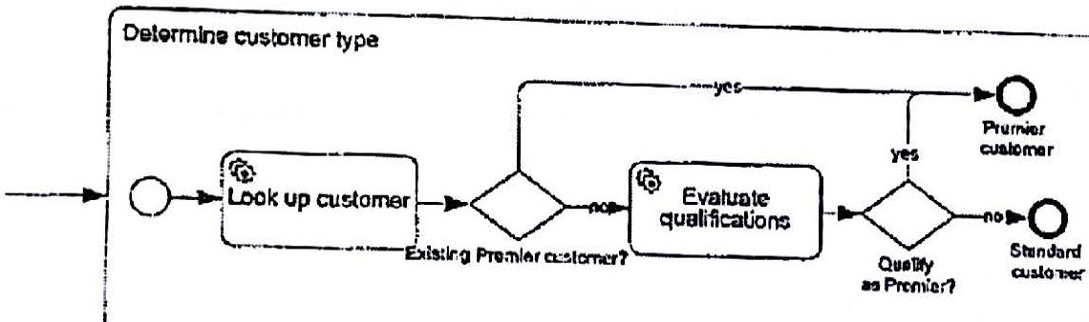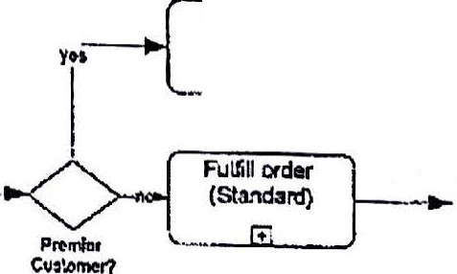

Fulf.11 otdor--)

(Premier)

__m_J

Figure 5-1. Distinguishing subprocess end states as separate end events aids top-down

traceability.



AJJ *this* adding of end events and attention to labeling might seem at first like needless bother; Modelers often asswne that everyone that will ever look at their BPMN diagram is already

··• familiar with the process and the terminology used in the diagram. However, that is not always the case. Matching end state and gateway labels creates a persistent visual link between parent and child-level diagrams that makes the logic traceable from the top level down even if the viewer is Wlfamiliar with the process or its terminology.

**tep 1. Determine Process Scope**

Top-down modeling starts with agreeing on the *scope* of the process, where it starts and ends. The process does not have to be customer-facing, what we sometimes call end-to-end. It

56 I Chapter 5. The Method

r""'". ----·----- llZ!mll:!l!Bi!------------

**Scanned by CamScanner**

- - ·......... '''- -.·- ......._ ...

could be an internaJ .function c

*t* · *Y* wi m

. h I

thjng

is t at t :iere

*is* agreeme per1ormed entirel 'th.

a single department. Ine important

. f·c

modeI

f . . ore

mg e 10rls,

h u 1ect

after weeks n on the scope befi

d . .

elmg begins

mo

. You don't want your

break down .

m

rocess JS

a dispute *ove·*o mterviewing s b'

matter experts and other stakeholders, to

question *to* answer but yo

r w en the p · actually complete. That is often a difficult

detai.ls.

' u Want to have thos·e d1' scuss1·ons *before* di.ving into the process

In this first step of the Meth d .

couJd require mo th 0 ' I am usmg the tenn "process" a bit loosely, since it possibly re an one BPMN w 'JJ . . .

always means a

.

repeated actio ·th

process.

11 d .

e discuss that more m Chapter *8.* But it

.

. f n w.i *a* we - e.fined start and end not a continuously ongoing usmess unction TI I . '



b

* 1e <ey quest10nsfor now are these:

1. Ho:V dos the process stnrt? For example, is it on request, either from an external entity or internal task performer, or is it a regularly scheduled process?

2. What determines when it is complete? Once an instance is complete, there are no further actions on it possible within this process definition. Those would have to be part of a separate process modeJ. For example, if your *Order* process ends upon sending the invoice, activities related to collection of payment are not part of this process.

1. What does each instance of the process represent? Normally this is related to the start event, as we have discussed. If the start event represents a request, then the instance normally represents the fulfillment *of* that request.
2. Arc there different ways that the process could end? In other words, does the

process have more than one end state?

*As* we have seen, an *Order* process could fail because of problems with the buyer's credit, or the ordered. item is out of stock, or for various other reasons. Should we say that such a

process has two end states, or more than two? There is no right or wrong answer. ncomes

dmvn to how many distinct end states do you want to identify for analysis purposes or possibly monitor in actual operation? If a possible end state occurs very infrequently or is not worth distinguishing from some other end state, don't represent it *in* the model. BPMN is there to serve *you* in your modeling needs,revealing as much or as little detail as you require.

'There is no process diagramming to be done in Step 1. You have completed it once you have general agreement among your stakeholders as to the answers to the four questions above.

***Scenario: Car Dealer Order-to-Cash***

To illustrate the Method, we will use a process familiar to many of you from the buyer's perspective, purchasing a new car. But here we wil1 imagine *it* from the car dealer's perspective, the seller's order-to-cash process. Let'sgo through the four questions one by one.

When does this process start? We use this example in my BPMN training, and a student may suggest that it starts when a customer walks into the showroom. But I don't think that is correct. Certainly there are sales activities that occur when the customer walks into the

Chapter 5.The Method I 57

**Scanned by CamScanner**



!' **f!!p!** ''* **=ew-inmmsm I 'f'CP**

'\

I

\

* + no "order" when the customer

5

showroom, but they are not part of the order process. There 1

" */1* • the BPMN sense.

first walks in. In fact, there may not even be a process m

. . .th d I agree with that. OK, what is an D1en a student typically offers that it starts w1 aI\ or er. . . . 1 d ? Does any order in that context? What form. does H take? What information does it me u e.

money change hands?

As I . . ,Iam in the process of buying a new car myself so 1can tell you exactly what it

wnte this

·, .

meant in my case. An or4er is an agreement from a parli.cular buyer to buy a particulr car,

or a detailed specification for a car -make, model, color, and options -for an agreed price. If that car is not in the dealer's possession, it could be acquired by trade with another locl dealer or custom-ordered from the manufacturer . In any case, the buyer's agreement is always with the dealer, and what we are concerned with is the dealer's order-to-cash process.

At the time of the order, a small refundable deposit might be required in order to reserve the car or to secw-e the purchase from another dealer or the factoq. However, the proGess is not complete until the full amount of the pm-chase is paid and the buyer receives the car. For a new car, that usually occurs days or weeks later.

An instance of this process is a single order. But what if the buyer purchase two cars? Is that one instance or two? It depends. If this is considered a single financial transaction -there is a single closing with payment nnd delivery of both cars together -then itis one instance. If the two cars are treated as separate financial h·ansactions with possibly different closing dates, then it is nvo instances. It is best to consider and resolve such "gray areas" when scoping the process to be modeled.

Successful closing of the transaction represents the normal, successful end state of this process. Let's call it *Transaction complete.* But are there other encl stateswe want to consider? In thiscase there are. Here we 0111y want to count those exceptions that occur with sufficient frequency that they affect the overall business. It could be that the customer is unable to secure financing. In that case the process will complete in an exception end state we call *Financing unavailable.* And there is another exception that could occur when the car must be ordered from the factory. It could tum out that the projected delivery date is later than estimated at the time of the order, and the buyer cancels the order. We'll call that end state *Delivery date unacceptable.*

.,



·"'



l

t

\:

We could consider these two exceptions just technical variations of a single end state, t.,

*Transaction failed.* But our dealer in this case wants to distinguish them because they uggest -

problems in separate parts of the organization. *Financing unavailable* suggests a potential G problem in the Finance department, since an order should be initiated only if the buyer is - thought to be credit-worthy. *Delivery date unacceptable* suggests a potential problem in the l:

Sales department, since the actual delivery date for the ordered vehicle was not estimated . properly at the time of order.. Identif ying these as distinct e11d states implies w want to l

understand their cause and handling as individual exceptions. For example, we mlght want t

to think about specific improvement actions that could reduce their frequency of occurrence, or actions that could reduce their impact on the business when they occur.

f,

58 I Chapter 5. The Method

t

---------------------1

l:

**Scanned by CamScanner**

 

**steP 2: The High-LevelMap**

The next step in the Method is t d fi ·

o ap. us is srmply

. . ..

of the ma

1or activities

of the

* e n.e the I-Tio-h-Level M TI . . .

.

an enumeration

BPMN diagram, which is *ae* procteesds, ideally ten or *fewer* in order i-o represent the top-level

e

edi·ti·on of this book, I drewo tnheerahi

_from the h1·8h.-I :'d map, on a single page. In the first

1

now I think it mioht be b tt . gl level n1ap as a linear sequence of BPM!'J activities, but

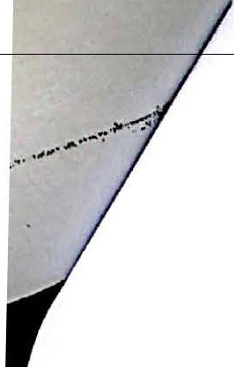

BPMN diagramin"th e er simply to think of it as a *list.* We *will* turn it into a top-level

enext step of the Method. .

Since the high-level map is . t .

1

. In . · JUS a Ist of the process's major activities, this step should *be* very

1

sunp e. practice howeve ·11

. . ' r, you WI probably spend a while on *it.* 'fhe activities in the map

me no a sampling of process activities,with more details to be added in between them later

on. It 15 better to think of them as *containers* into which those details *will* be added.

The steps in the high-level map must be "activities" in the BPMN sense, meaning actions performed repeatedly, each with a weH-defined start and end. Moreover, the *instances* of each activity in the high-level map must be aligned, having one-to-one correspondence with each other and with the process instance.

Other factors help guide the selection of high-level map activities. Remember that in BP.NIN, the start of one activity is usually triggered by the *completion* of a previous activity, not at reaching some point in the *middle* of the activity. Also, if the governance of the process is distributed across multiple parts of the organization, steps in the high-level map should ideally match up with those governance boundaries. And, of course, we would Jike to restrict

the count *of* high-level map activities to ten or less. These considerations guide definition of the high-level map, but it will require considerable time and ruscussion with process stakeholders.

Finally, when the outcome of an activity affects the subsequent path of the process instance, we nee.cl to think about *the end states of each activity* in the high-level map. End state names should be brief but descriptive.

***Scenario: Car Dealer Order-to"Cash***

In our car dealer order-to-cash scenario, the Owner meets wi!-h Sales Manager, the Service Manager, and the Finance Manager to come up with the high-level map. They collectively agree on the following activities:

* + *Finalize order.* There are slight differences in procedure and price depending on whether th_e car is available from dealer stock, acquired by trade with another dealer, or custom ordered from the factory. This activity is governed and performed by the Sales department. End states: *Reserved from stock; Dealer trade; Orderfrom factory.*
  + *Acquire carfrom local dealer.* This activity is conditional, performed in some fraction of process instances, not all of them. This activity is also governed and performed by the Sales department. End state: *Car received.*

Chapter 5. The Method I 59

**Scanned by CamScanner**



-=_,...,,.. .. - =-·.,_......---....·-·-·· ..

d by Sales. *J1* the factory



also conditional and per.fo::*Finalize Order,* the customer

* + - *Acquire ca r from factor y,* ti'mated at the tun *ll 'd*

.

delivery date

later

h<i the one es

:*Car*

. *'*1*;* 0.*·der cance t* ·

. " .

is t d states

*receive* '

could cancel the transaction. En . tailed options and clearong up

- . activity includes dealer-ins car comes from stock,

* + - *Prepare car for delzvery.* This - re ardless of whether the d b the Seivke

the car for delivery to the customer, - overned and performe y

dealer trade, or factory order. It is g

department. End state: *Read y.* It an start as soon as

- F' ce department. c .

* *Arrange financing,* performed by the inan . h . .ring and preparing the car.

*Finalize order* is complete,

* · parallel wit acqui

runnmg m .

End states: *Financing confirmed; Financing urzavmlable.* l th

d b the Finance d i-,..,..cnt, comp etes e

eparuu

* + *Close and deliver.* 1his activity, pcrforme Y . . t ·als to the customer.

financial transaction and del. th · d remstratton ma en *z* · are complete.

1vcrs - e car an o· *d*

It may not start until both *Arrange financing* and *Prepare car for e ivery*

End state:*Transaction complete.*

* *Hand le order*

.

*canccllatzon.*

. _ . .

This achv1ty is

on1*y* perf d when the order is cancelled

before the dosing. It i.s performed by the p·mance department· After handling the.

orme .

cancellation, we still want to distinguish the process-level end states. End state.

*Delrve-ry date unacceptable, Financing unavailable.*

**Step 3: Top-Level Process Diagram**

Now that we have our high-level map, we can tum it into a top-level BPMN diagram. 1be process starts on request from the customer, so we will use a Message start event, *Receive order.* Each high-level map activity becomes a subprocess in the diagram. In the hierarchical rnodeling style, we will later expand each of these activities in hyperlinked child-level diagrams to show the details of each step.

Inthe Method and Style approach, each activity that is *conditional* in the high-level map will be drawn following a gateway that tests the end state of the preceding activity. If the gateway has two outputs (gates), we label the gateway as *[endstal-e1]7,* where *[endstate1]* is the name of one of the end states of the preceding activity, and label the gates *yes* and *no.* lf there are more than two gates, we simply. label the gates themselves *[etidstatel ], (endstate2],* etc. We don't need a gateway to merge alternative paths;just connect the sequence flows directly into the downstream activity.

If an activity is perfotmed *concurrently* with other activities in the high-level map, we can split the flow into parallel paths either using a parallel gateway or simply two sequence flows out of the preceding activity. If a dm\1J1stream activity requires completion of two or more parallel activities,we must use a gateway join.

Inthis way, construction of the top-level BPMN diagram from the high-level map becomes a

fairly mechanical exercise.

60 I Chapter 5. The Method

**Scanned by CamScanner**

*scenario: Car Dealer Order-to-Cash*

we'll start by considering only the "ha ,,

*Transaction complete* end state d . PY path of the process, leading Lo the successful

and *Arrange fi'nnncing* The

*1* an tgnormg the ·

. exception

end states of *Order car from factonJ*

states we don't label · resu1t is show · F

tl b n m igure

52. Since *Finalize order* has three end

each·'

to an end t 1e su sequent gat

as a

. but instead match the name of

gate

*t* T eway

question,

initiated in parallel. -ee

wo sequene.flows out of *Finalize order* means both paths are

. b N1 D-gatcwny JOID means both *Prepare car for delivery* and *Arra1zge*

*ftnancmg* must e complete before *Close and De11·ver* can start.

Order ar Imm

f.xtory

--- El

_ .m_. _ r

'--

AajUilC c:ir from Pl"J)Jre "'°'rot

dealer dcltvcry



fiL._.

1------- l'Ol!l"CO. _J

!Amlngeftn ndng .._

l Fl

ClOt and *do 'ver*

Figure 5-2. Top-level BPMN diagl'am, happy path

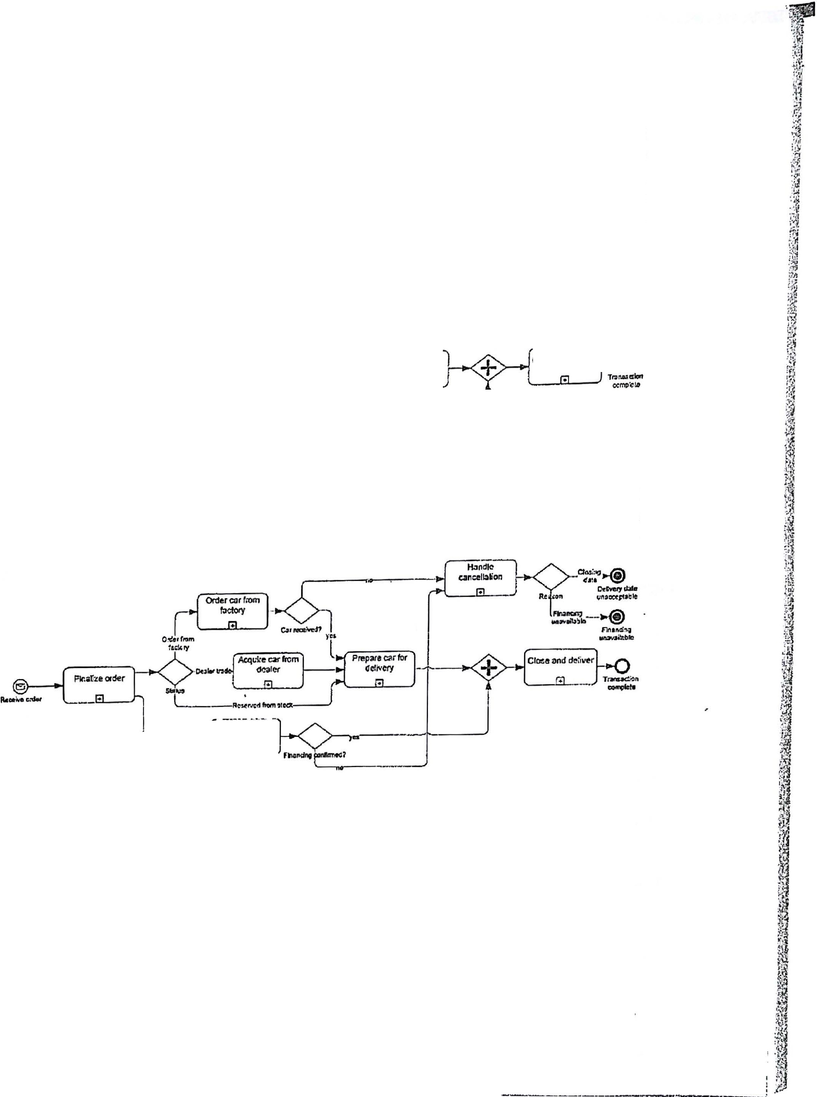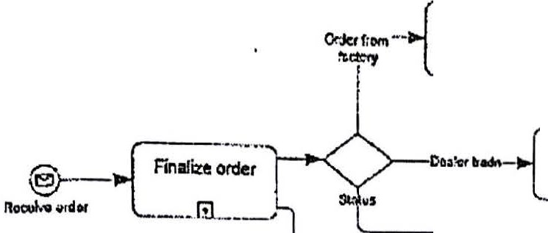

TI1at was the happy path. Now let's add the exception paths. We want to show all the end states of the process as separate end events in the top-level diagram, each labeled with the name of the end state. The result is shown in Figure 5-3.

..

'



'---o..i"'ronge,,,.ncfng

Figure 5-3. Top-level BPMN diagram, including exception paths

Recall that the xception end state *Delivery date unacceptable* is the consequence of an exception in *Order car from factory.* If that exception occurs, we need to perform *Hanclle cancellation* and then end the process. Because there is another process path inparallel to this one, we need to use a *Terminate* end event at *Delivery date unacceptable.* Otherwise, the financing path would continue and wait forever at the join.



The same thing applies with *Financing unavailable.* If *.Arra nge financing* does not end in *Financing confirmed,* we need to abort the process by performing *Handle cancellation* and then ending *in* a Terminate. Otherwise the *Prepare carfor delivery* path would hang at the join.

Chapter 5. The Method I 61

tf....M.f.!47, . .P.'.!C.0....,..0.i.i..F,f'.f,f.f•FI .•,....._.,..,........,_...,...,,.,...,....4.l,i,.J,..JQ,j .••_,.i,..,,.,"h.4di,.,,.._,,,,.,,.... •

Scanned by CamScanner

**mwm@.14** ,,, **or** ' **F**

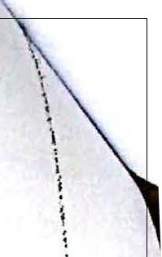

* akes tl:i.e diag:ra.ro slightly rn01:e

. .

* the top-level d1aO"TaW,but it rn fr F1'gure 5-4, wh1ch is

o· this otn

We could have drawn lanes m ,, tty ,, y0u can see ssage flows yet! It is

th

convoluted and ted. to make pre · we have not

lous A d

dded any me a ·

·n the chlld-level

semantically equivalent to Egure 5-3. n l d' gram and just put em 1

often better to omit lanes

* the top-leve ia

m ,

diagrams. -

..

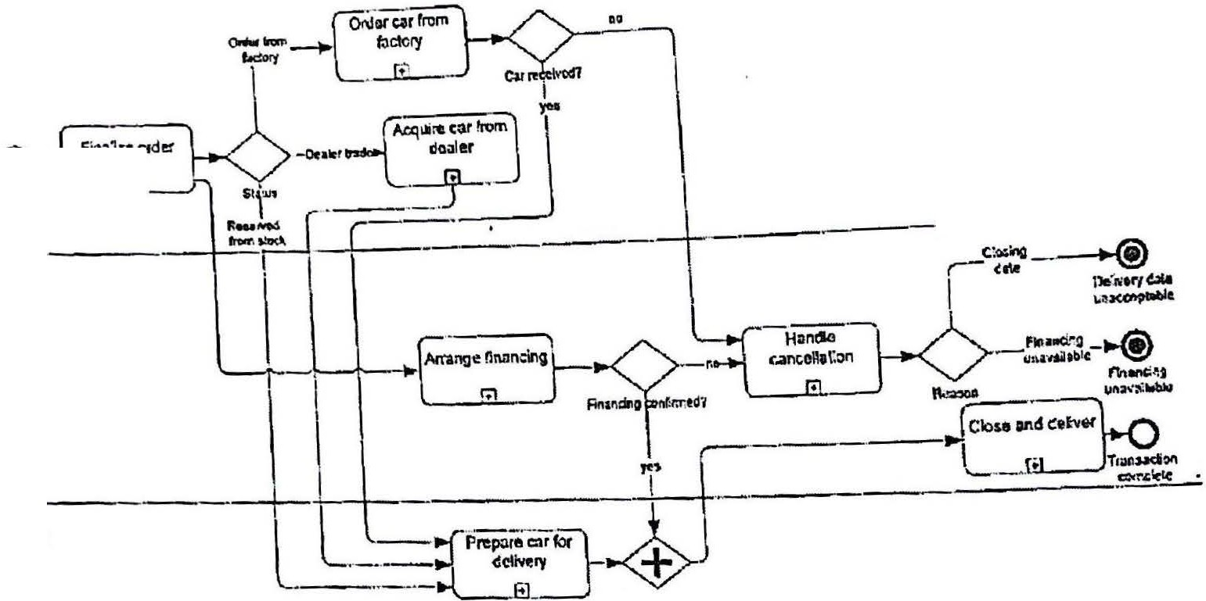

..

"'

Cl)

..c. --·

- G.._

---------

B

g

l:!

0

8c

"

c:

ll:

.

Figure 5-4. Top-level diagram showing pool and lanes -'

1-

,

**Step 4: Child-Level Expansion**



The top-level diagram tells you how the process starts and ends,but it reveals little about the internal details. For that you need to show the child-level expansion of each top-level activity. In hierarchical modeling, each is drawn on a separate diagram, hyperlinked to a collapsed subprocess in the top-level diagram. Good BP1v1N .tools create those hyperlinks automatically.

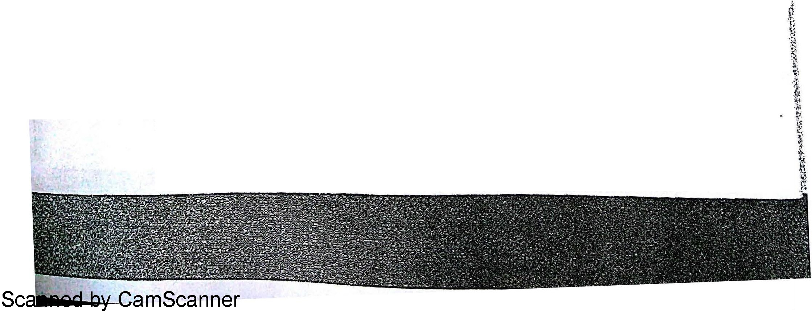

1be child-level expansion must have a None start event. Activities in the child-level

expansion can include collapsed subprocesses, which would then be expanded in another <t diagram two levels down from the top. You may either enclose the child-level process in a · pool or not If you draw the pool, it must be named the same as the pool of the parent level, :z.

l

).

Lanes arc defined independently at each process level.

i.e., the name of the process. You may either include lanes in the chUd-level diagram or not.

Remember to create a separate end event for each end state of the high-level map activity >.,

_,

identified in Step 2, and labe.l it with the name of the end state. If you want to modify your ·

list from Step 2, it is OK to do that here. Just make sure that if a subprocess is followed .by a gateway, the gateway (or gate) label matches the label of one of the subprocess end states.

62 I Chapter 5. The Method

*scenario: Car Dea/*

*er Order-to-*

*To* illustrate we'll *Cash*

' cons·d

1

upon receipt of an . er here the fi t . .

'f' . order a d rs activity I

specr 1cabons for ' ocument fr on y, *Finalize ord*

states:*Reserved fr* a car), and the agreed o1:1 the customer that iden We know that it starts we will . *orn stock,* ine . . . pnce. And we kno . es the buyer, the car (or

from *t*h acquire it from a lo aal nmg it is available from d lw .that it could end in one of three

e manUfacturer

c dealer,·and *Orderfro*

ea er mventoiy,. *Dea*z*er trade,* meanino-

eventsm·

order to b

* 11le ,.,i..'ld-level

*mfactory*

mearu·ng

0

will custom order

e cons·

15

1-1u

expans·

*/* we it

must h fl

t 10n

ent With the parent-I . ave ows leading to those three end

eve1 diagram.

*r* archdC?:il

r.:---- -

r,.,.,..,.,.,,,

"""llt.do'f?

o-f£ i :i-·

l!..:!<!Q•fer lr.ldadcit 1

--·--J

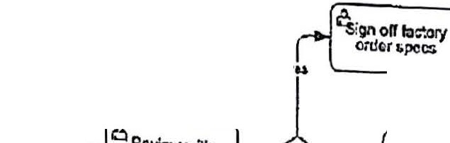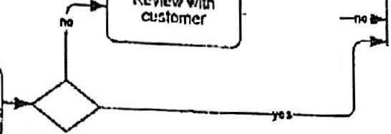

L_· ReellleL'IVClllDty n'.:9r,.,,,

Figure 5-5. Ch1'ld l 1 -

- eve expansion, *Finalize 01·de1'*

Step 5:Add Message Flows

InChapter 3 we added the customer request and final stall.is message flows before we did the child-level expansion, and I stiJl often do it that way. But here I created the child-level expansion first in order to talk about the general issue of showing "collaboration", i.e., message flows, inyour.BPMN models.

Message flows are not required in BPMN. 1he spec says you can draw them or not, as you choose. However, Method and Style says you should draw them, because they add valuable information to the diagram. They show how your process interacts with the customer, seivice providers, and other internal processes. In other words, they provide valuable business *context* for the process.

The downside is that message flows also add visual clutter to your diagrams. Through years of BPMN training I have found that students with an "architectural" inclination love them, but others may find them annoying. The solution that I use in training is to include them in the model, but a11ow them to be hidden from users who don't want to see them. This is easy to do in Visio and similar tools that support dravving "layers," but it may not be possible in

other tools.

Message flows always connect to either an activity or a Message event in the process. Usually the other end of the message flow is connected to the boundary of a black-box pool. Even if that pool represents another internal process, it is best to represent it here as a black-box pool.

Chapter 5. The Method I 63

anned by CamScanner

•

r

!.

*!*

b ool ) In any case, you

(In the model of the other process, *this* process becomes a black ox P

- XML. hema demands

can't simply leave one end of the message flow clangl. · ace·the sc

mg m sp */*

a valid conneclion at both ends.

h than the *certainh/* of it.

In some cases, message flows indicate the *possibility* of a message rat er *·ust* be

In other words, a message flow out of a User task does not mean that the message *m* . .

a

sent but that it *could* be sent. And similarly, a message flow .

mto

U task does not requue scr ' · h

* the arrival of the message in order to complete the task. (Inthe Level 2 palette, we'll see ot er

task types, Send and Recei.ve, that do requi.re the sendm'

g and. recei·vi·ng, but we ar.e not there

yet.) Also, if there are multiple message flows connected to an activity, their order of occurrence is ambiguous. Sometimes it is implied by the label - for example, an *Info Request* message would generally precede *Info Response -*but in general you can't tell. ·



Inhierarchical models, a basic Method and Style principle is that the message flows should be consistent between parent and child levels. If a co11apsed subprocess at parent level has three outgoing and lwo incoming message flows, then the child-level expansion should have the same number, and their labels should match the parent diagram as well. This is another example of top-down logic traceability. In the parent-level diagram, you cannot tell by inspection the order of those messages, or whether some of them are conditional. You get a much better idea from t11e child-level expansion, where those five messages are replicated.

Consistent application of this principle means that all the message flows inthe entire process model are prc>.sent in the top-level diagram, and that can be quite a few. If they don't all fit, it's acceptable to use visual shortcuts like combining multiple message flows into one, with appropriate labeling, but it's best to show them nll if you can.

***Scenario: Car Dealer Order-to-Cash***

Figure 5-6 shows the top-level diagram with message flows. You see that while they make the interactions with other entities visible, they also add visual clutter. Take a look at *Order Car from Factory.* There are four message flows here, but their order is not obvious from the top­ leel diagram. Dy replica ting them in the child-level expansion, the message order, along

w1th the rest of the process logic, becomes immediately apparent (Figure 5-7). .

T

·

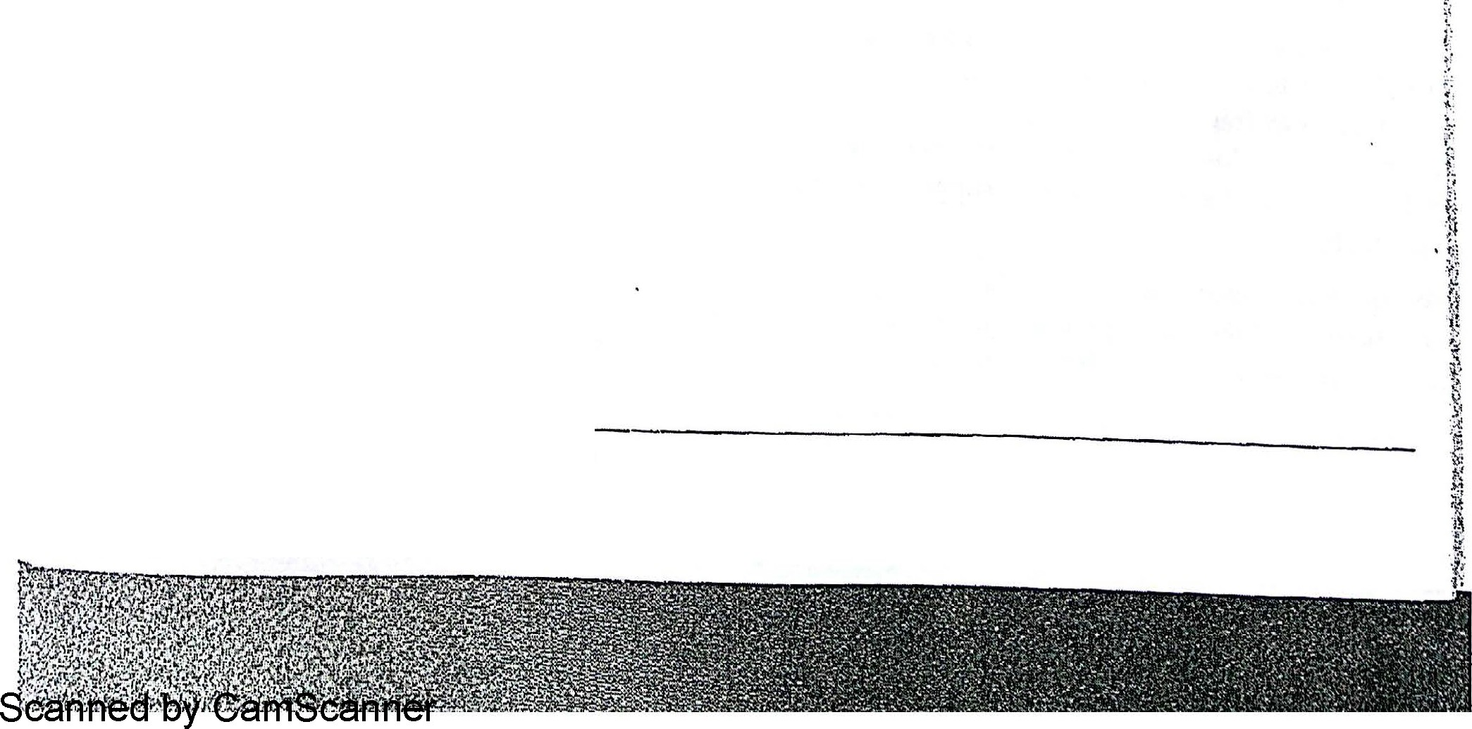

64 I Chapter 5.The Method

 

;

*:I*

a. 1

Figure 5 6. Top-level diag1·am, with message flows

_Jf>Pe f:ic:!::ry

0- L

order

r­

*·:*

Ft•<'>r*

8 Ro<:civc

prodClion



omp1e1ion dr.o

'•I

*:*

**Ftcr"Nbt**

!'



c

* I

Figure *5-7 Ordet· carfrom fa.cton;,* child level, with message flows

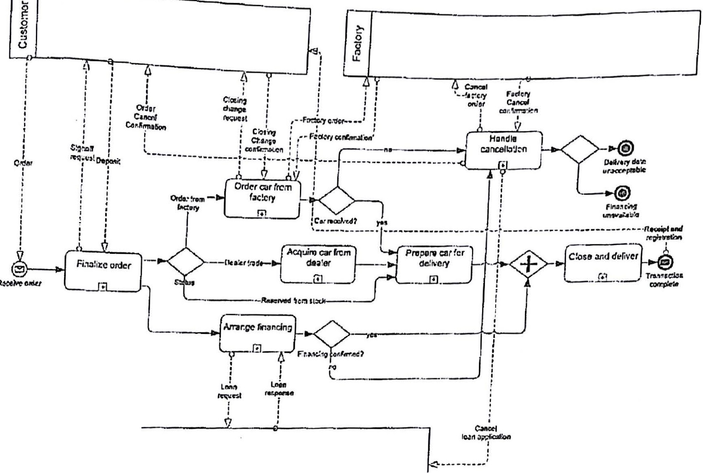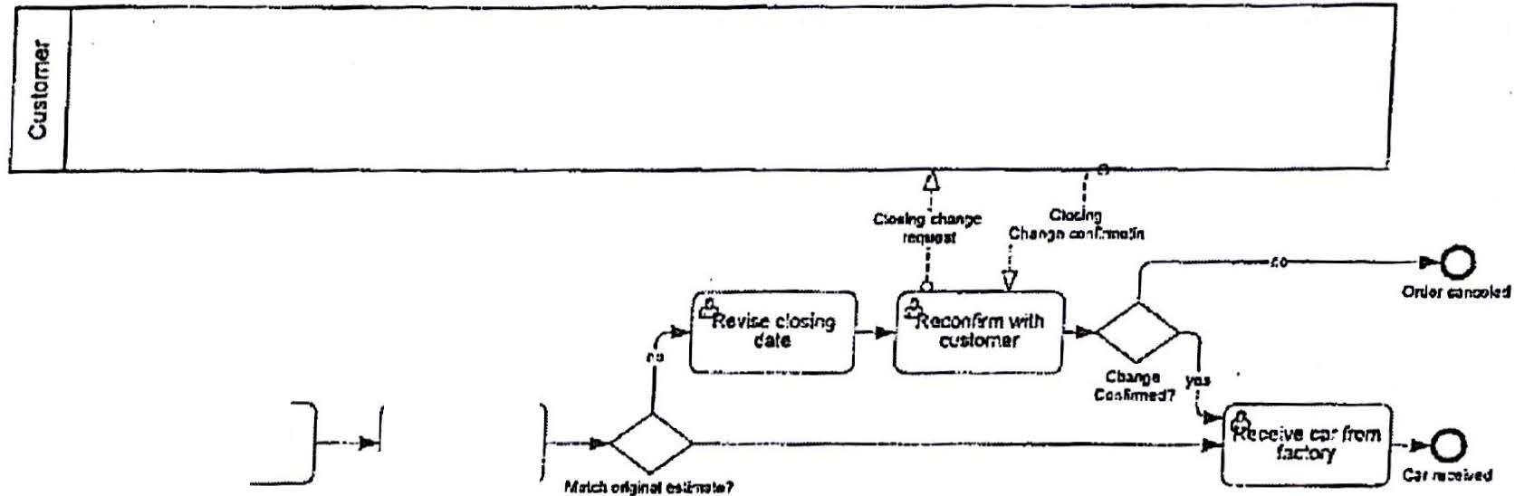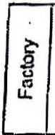

**Scanned by CamScanner**

Chapter 5. The Method I 65

I



In Microsoft Vislo, you

'

can selectively suppress the display of message flaws or any othet diagrnm element by placing them in a hidden diagram layer. This is far better than creating sepnrnle high-levol and detoikd models and trying ta )<eep them in sync. Just add a new layer, select the shapes and connectors to pul in that layer (Figure 5-8), and sel the pr.opcrties of ll>at laycr lo be invisible or, by coloring them light gray, barely visible. In Figure 5-9, only



the Customer pool and rnessnge flows connected to it are le£tinthe visible layers.

n: ---J .::..-- =--:...--::-.=-::_ . ------r \...7. -.i;·.-::- :·=- :-=·:·:... .-.-.- -:*.....-... :·*-:·.-· ·\ ·:

l..'. l·-r;

• }; I '

·-·----r-·1-..- \_::*t}"* ... ... · ·A .<;;" ... •··- ·.. . ,:;:,0p

-i•;_·,;.':-(-''.·,.:-. :' -""'

I I I ..,. ::; I ' *•.::*

.:l ...,.. ..1.·. .. · -"=' .!.!:.. !._;' - ·

I I I .;...!- •••• *...) !_,* - • .,..,L :i'iiir -,;;;;; ,;- ..- ··--- ·I "

-I ·-·,r· . \_ _ ___ L-::.:-:-7· -- --·----- ·-"'" r' ·--- "'--- -··--- -l IID :.

I lj I .

1 .,.,:,....,.... .. "'"' '(Lll' .. .--· -· . .

: I I .,... .....;;. . - I l [i;:_; J 1 ·

I I : *'";:.:'.;" -* ......, I \ -;:J j' :

·

I rI I

......,...._...... 'l

:t:__ ..____. ....:... ._

---

·f:

®--"l , ,.,,_ . .., ...,;.. - ,w...1.-......-.....CT:J -, ..

,_"'" L • •

# r:-:..-:-;-.--

. .:-: .. - - :

·-· ..-..--· !

*.2..* '-• t - - l

I

""'" .,. I

.- 1 .. v ·•

.,,._.... .. ·\

-I-.·-I.--,,_.----·--·----·""..·--...,..._ ,...<.1 --·"·--·-·--._,_............._...- .Il

Figure 5-8. PI:m·ng selected shapes in an invisible v·. 1

w=-rf-r

l \ 1510 ayer

: : ! i Cbl'I) l :

: I ! o.t.. "'-nt• I l

I. II

•: ··

...,...:11 l..., •

Ti T· Ii

l.--------

!.=:=.::.,1

iIr--------===-=::J,_.:,

I::_lr<>L::!;.. .

r;:;!.- *i"*

-.--'- Alb---1

t

-.;·---- -·- ---·----·· . .!.. :

: : I o•-· ""°" . ..,.., .

1 \ \

--L_a

.. ___:_ - ;::['.;;:

--;----·::::' .-=;;;: .

+ t"'"r:,'""' e ::..

*.-..·--·dl-·--_f* -. 'T11..>dlM

---EN-} · -- . ' J -po \

Figure 5.9, Top-level diagram With FC\Ctory and tender coll b . :,

66 I Chapter 5.The Method a orallon hiddell "

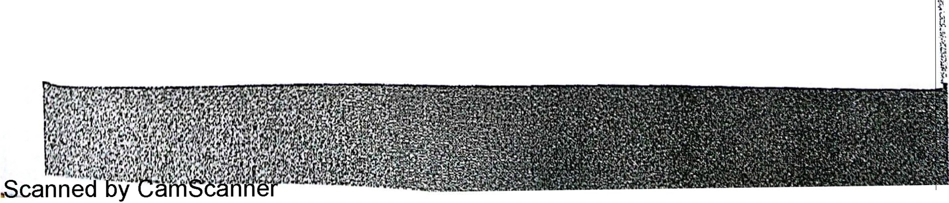



.,.,

..·. •* ..

**Method Recap**

***r*** \Ve'vc r.ow covered th M

* c i r.thod . Tl's pr lly .,i1npl\ r·:.illy. L1;l''l rcvlr:w th ,,1r.;p 1:

1. Agree on proccsr, *r* .

Possible

d ., ..cope, when ii slnrls Ll.nd end . .,..,11. ltit • *in:.t. net: rr:p-rr·.":<' nt* >,:1r1d

Sll

en \tes.

2. Enum crf'l tc m;)J.Or act' l ti . I . , 1· d . I

i

. iv c" In a ll[;n·lcvcl m:ip. ten nr fewer. nd1.,iri i•.: w1 t*··I:*



process mstancc· 1ni m· k . bout po. 'liblc end slo lc!l of acl1 ::ctiv1ty.

1

rea tt- lop·level BPM N <liner.im. ,\ rr.'.l nec ldgh-lcvcl map activiti · *.i.:;* :.ut7p: ><' ,··-:,

in i1 BP?vfN prss 1, 1•1ngrnm, wi• th one top-level c:id event p r prncc>,-;

gat-eways to show condition;il <ind concu rrent paths.

·I"

-· ....



d 1 IJ

Expar.d each top-level subproccs in *a* duld-lc\·cl di;:igr .-i m. r£ scbproa:c" il! p..-i:cri evel is followed by n gateway, match su bproccss end st.-i tcs to the "'n:c·wa;- *(o: ;.a!CJ* 1nbels.



1. Add business context by drawing message flow5 bct·,.;een L - process an:! ·X: >::1.'ll requester, service providers, and oer internal proccs. d wn '15 cl.:lck-:;ox pool.;. Message flows coru1ccti ng to coliaps"d subproccs.s J! pa-.: l::vcl s:toul- be replica ted with same nnme in the child-level dia5:am.
2. Rpeat steps *4* and 5 with add ilionnl nes!i_d I d.s, i!;i-..r.





Chapt r 5. Th l• Meth :-d I G,



**Scanned by CamScanner**